

**Student Portal**

**Usability test plan**

**Version:** 1.0

**Writer:** Sergiu Tripon

**Date:** 04/04/2015

Contents

Introduction 4

Requirements 5

Student 5

Academic staff 8

Administrator 10

Common requirements 36

Student, Academic staff, Administrator 36

Student, Academic staff 45

Academic staff, Administrator 53

# Introduction

This document details the events occurred during the usability testing phase of the Student Portal application. It is made out of 5 main chapters. The first chapter showcases the test cases that were created and used by the participant to test the application’s usability. The results are shown in the second chapter.

# Requirements

## Student

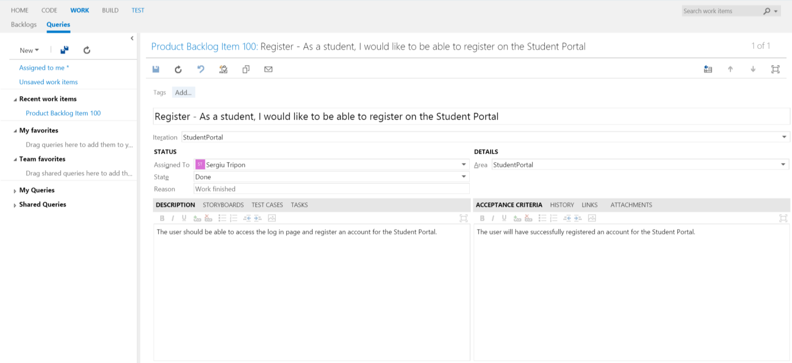

**Register** - detailed view of requirement

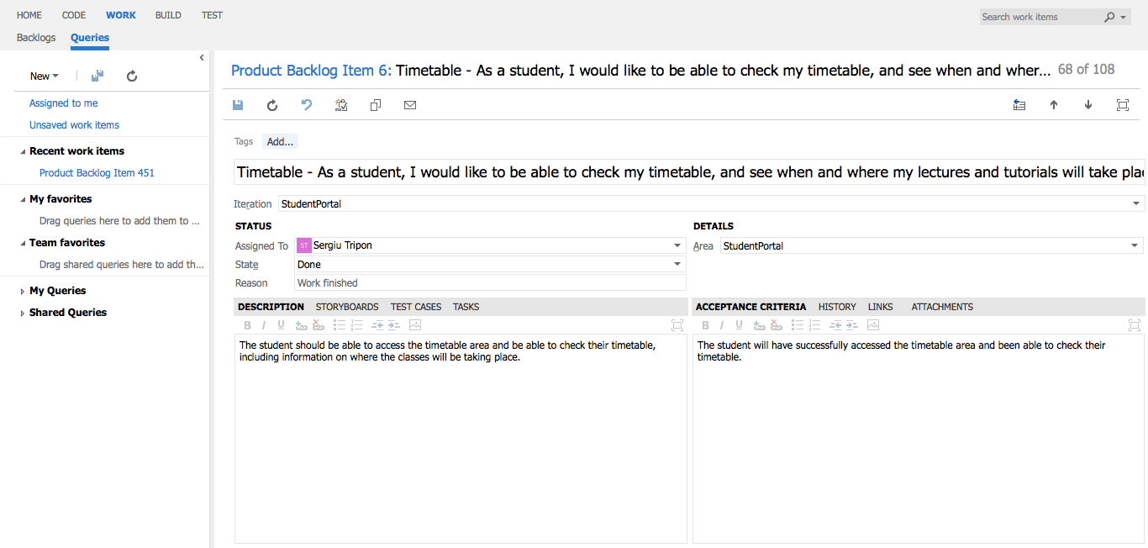

**Timetable** - detailed view of requirement

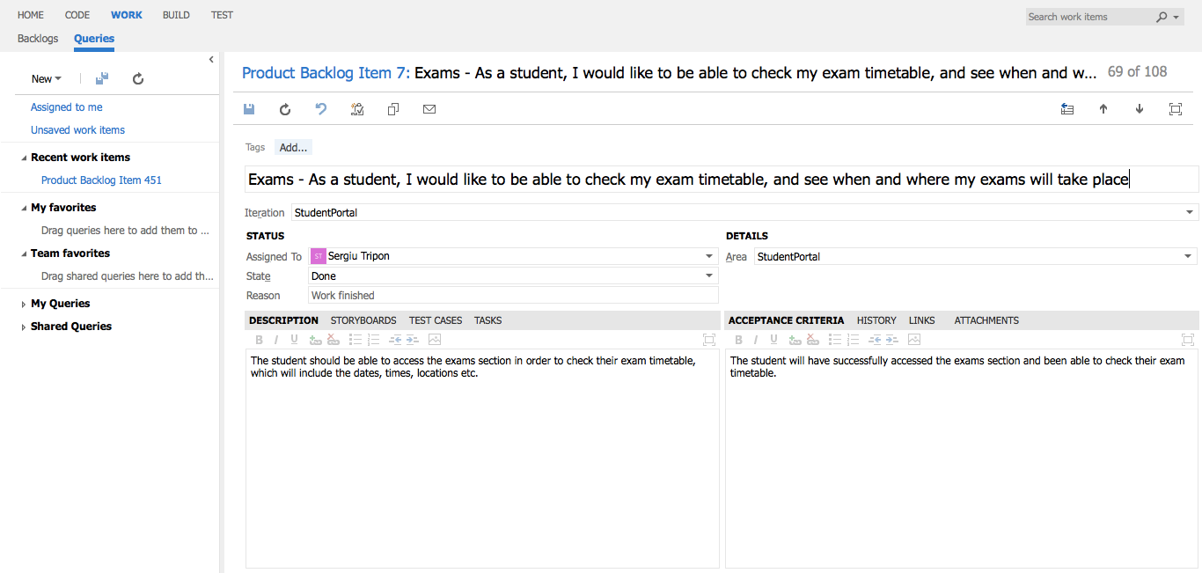

**Exams** - detailed view of requirement

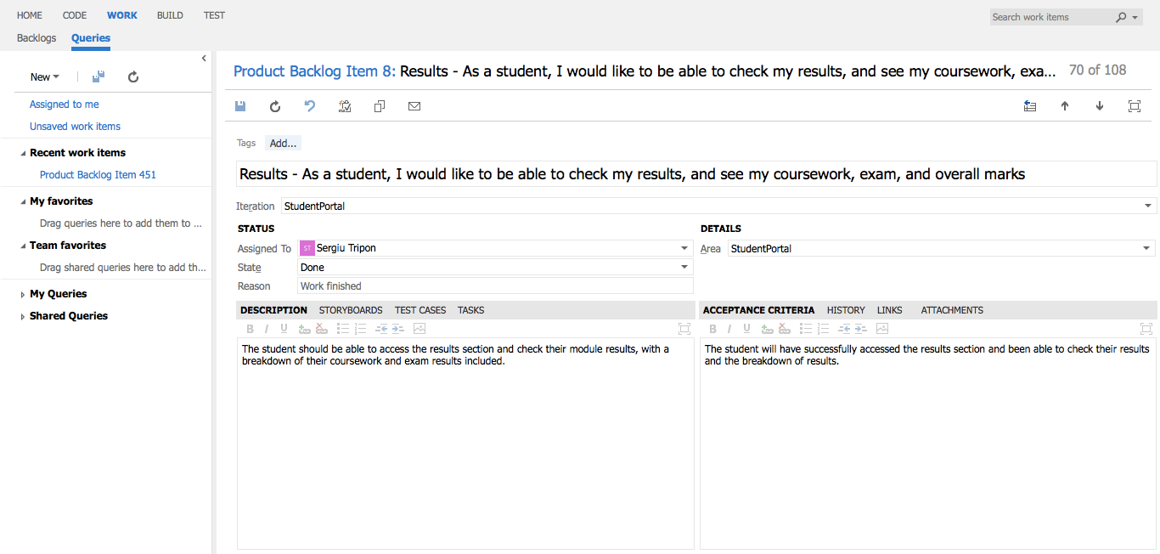

**Results** - detailed view of requirement

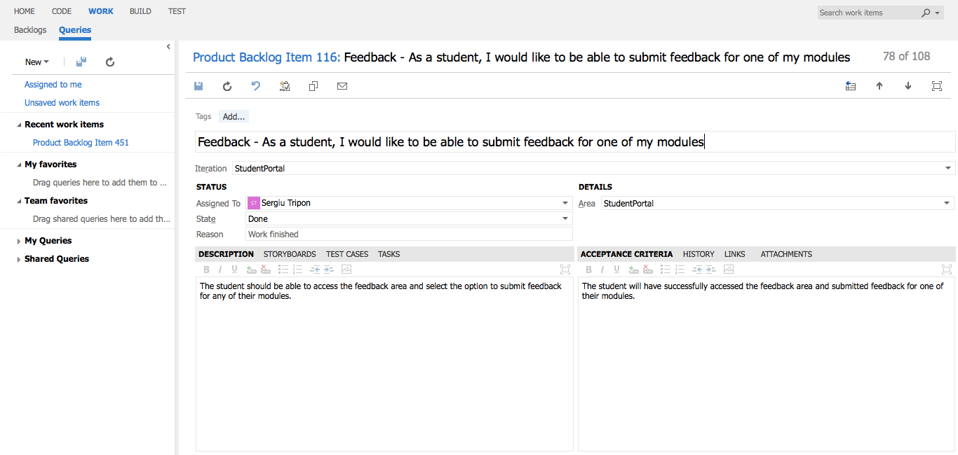

**Feedback** - detailed view of requirement

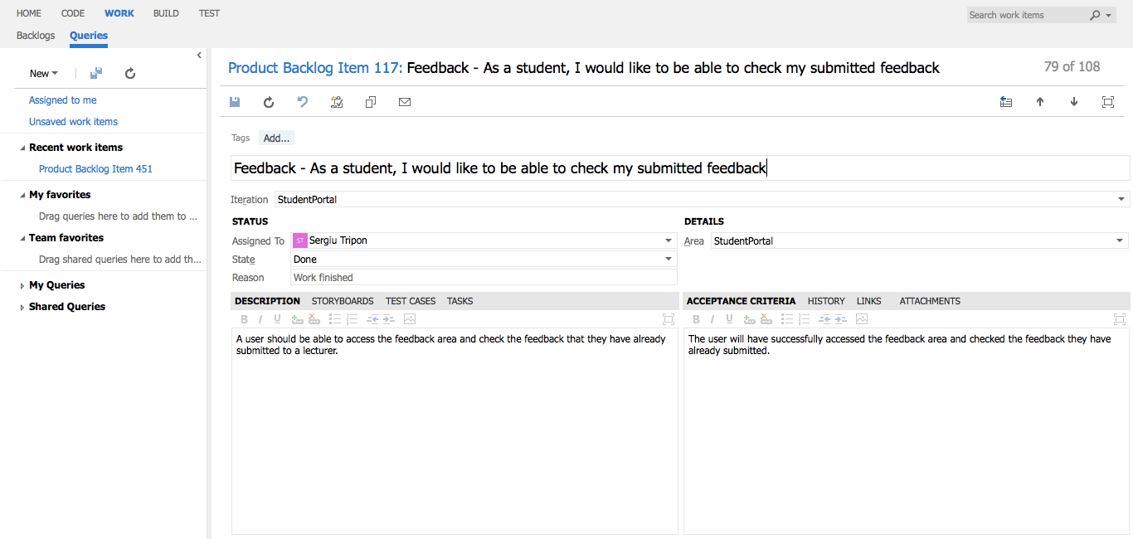

**Feedback** - detailed view of requirement

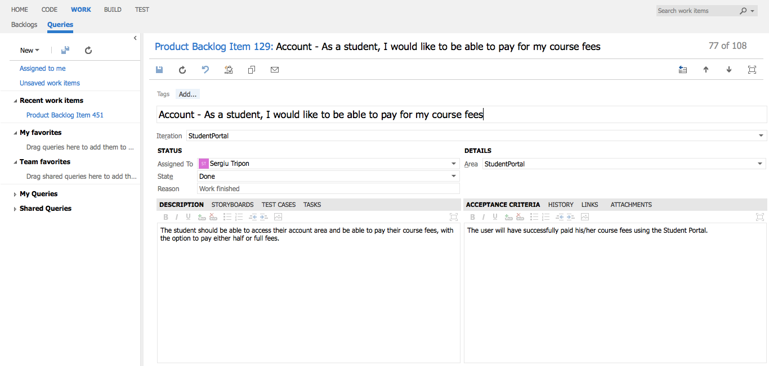

**Account** - detailed view of requirement

## Academic staff

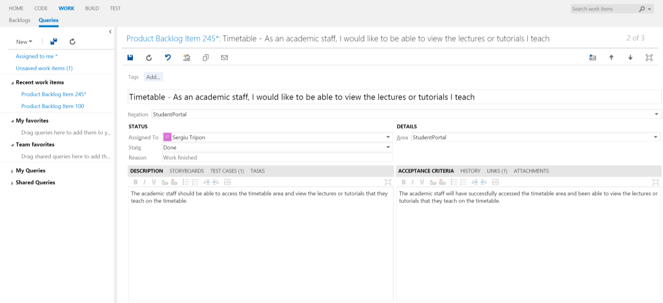

**Timetable** - detailed view of requirement

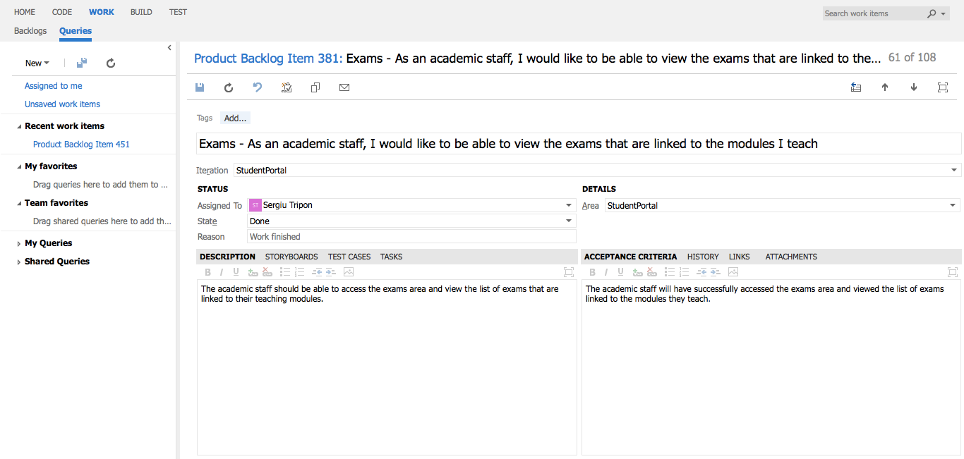

**Exams** - detailed view of requirement

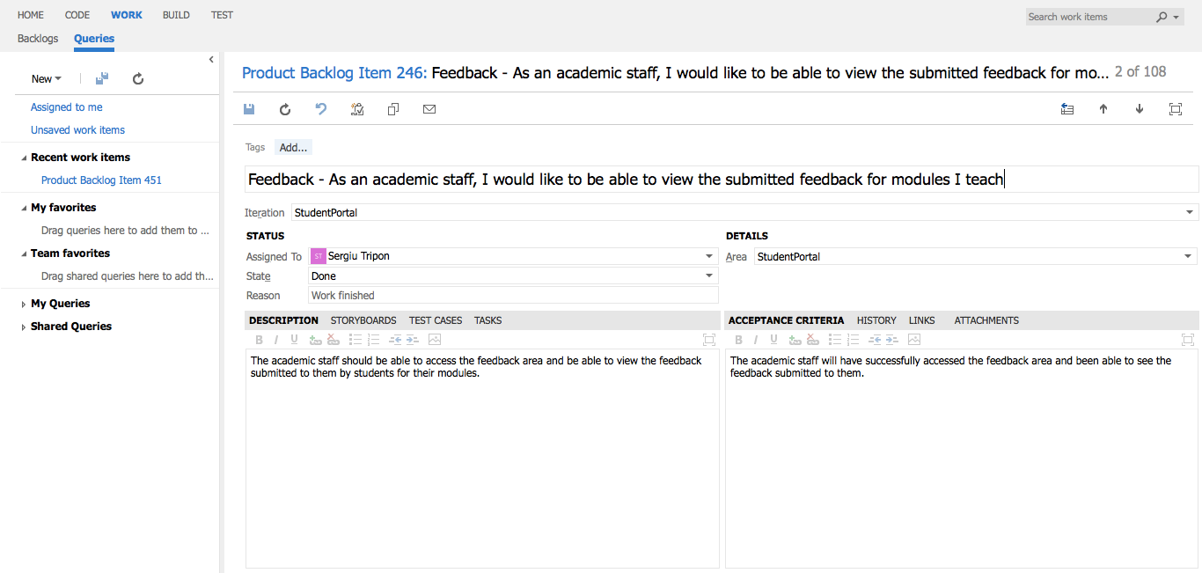

**Feedback** - detailed view of requirement

## Administrator

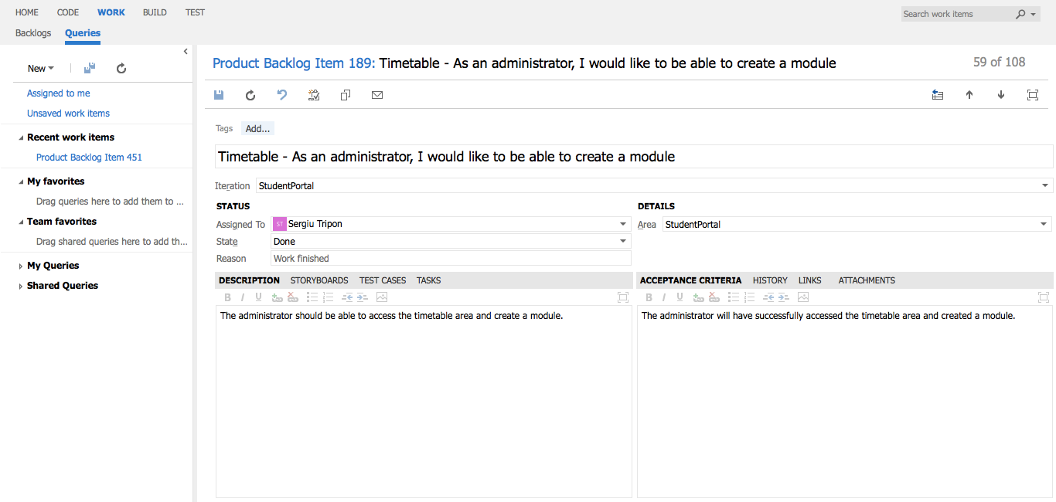

**Timetable** - detailed view of requirement

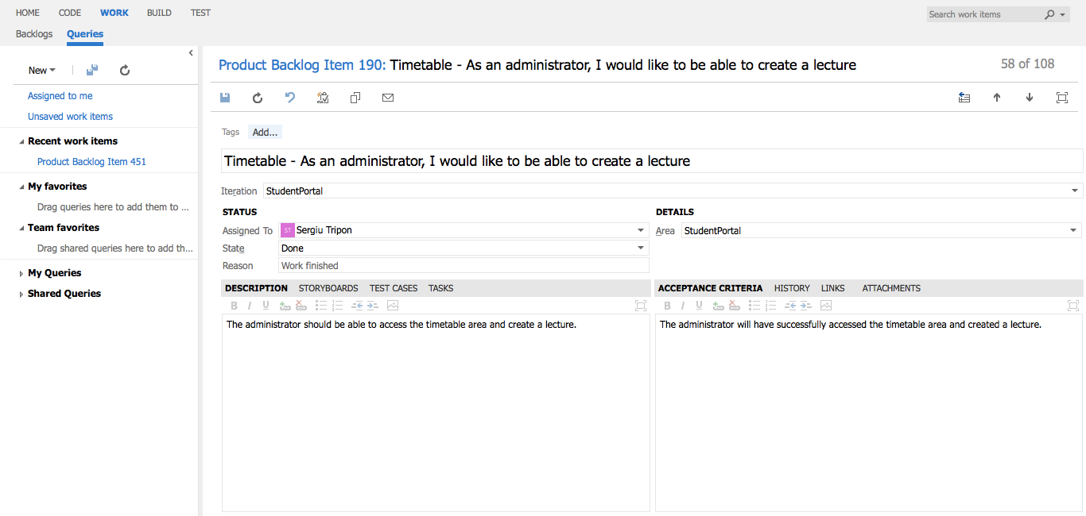

**Timetable** - detailed view of requirement

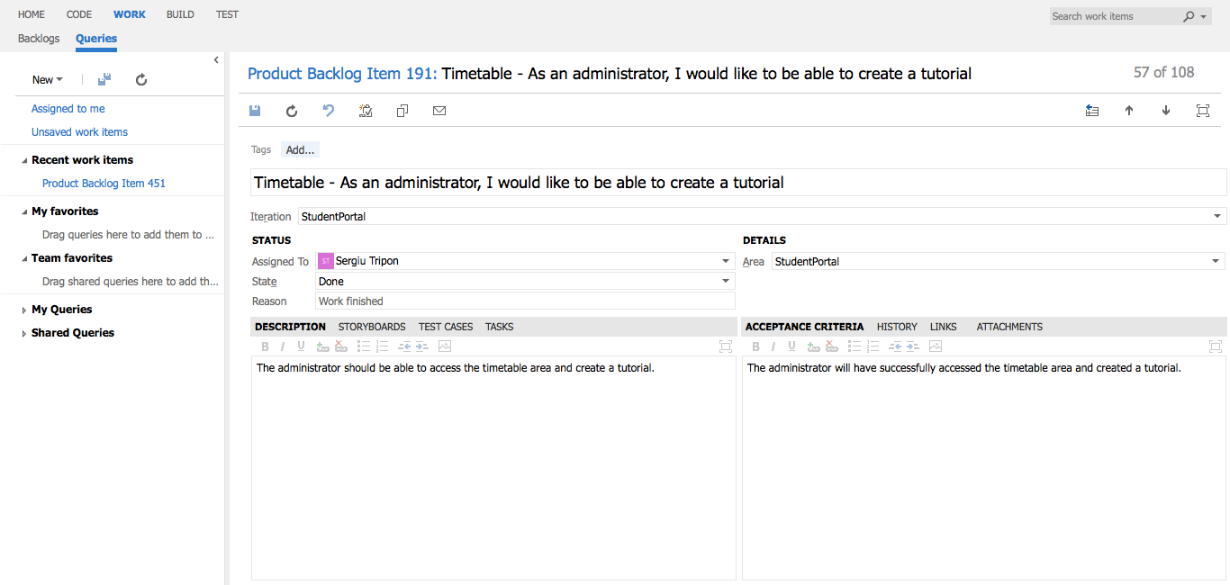

**Timetable** - detailed view of requirement

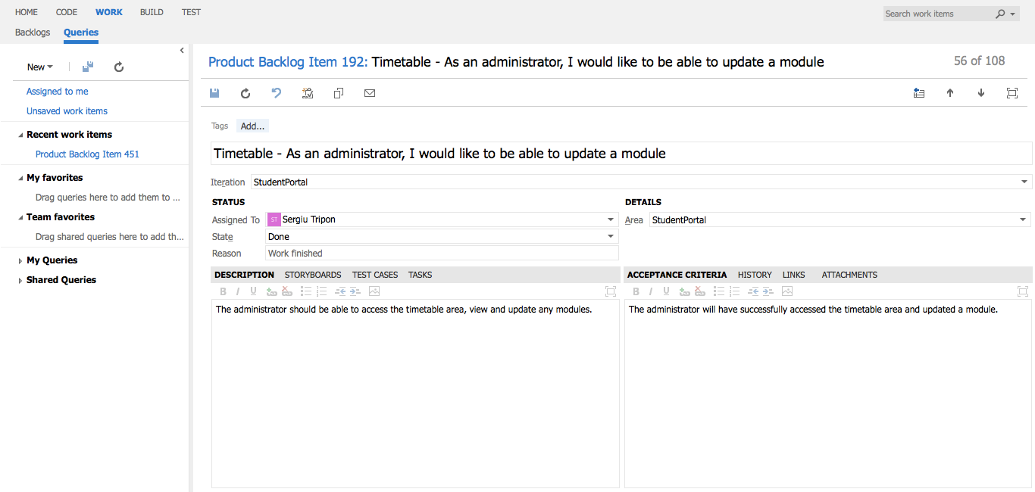

**Timetable** - detailed view of requirement

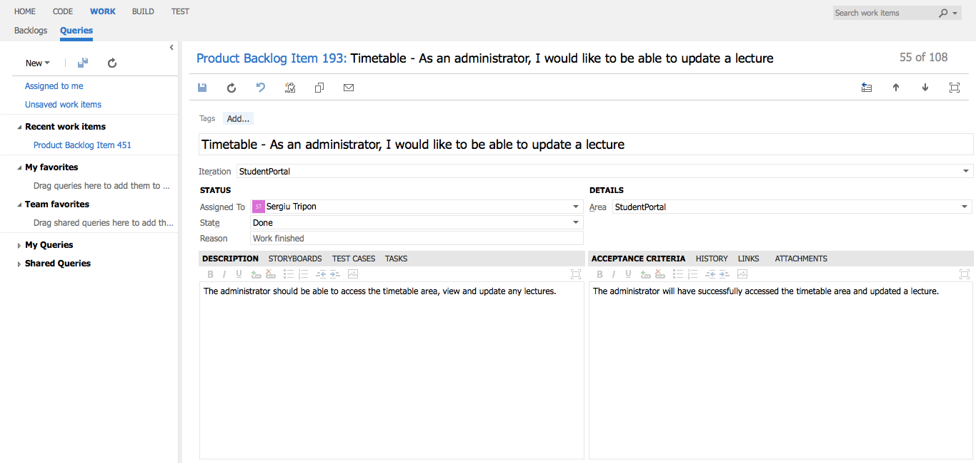

**Timetable** - detailed view of requirement

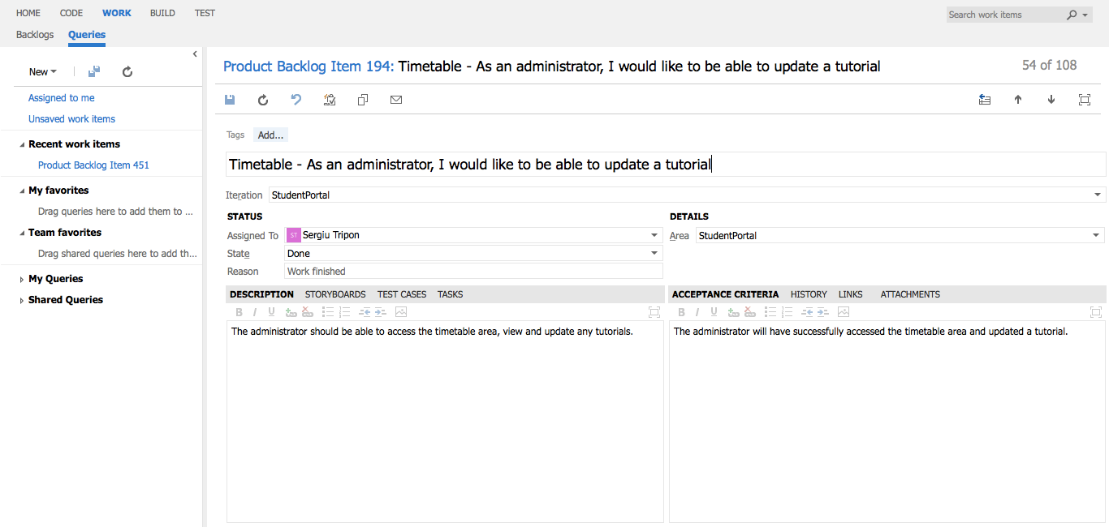

**Timetable** - detailed view of requirement

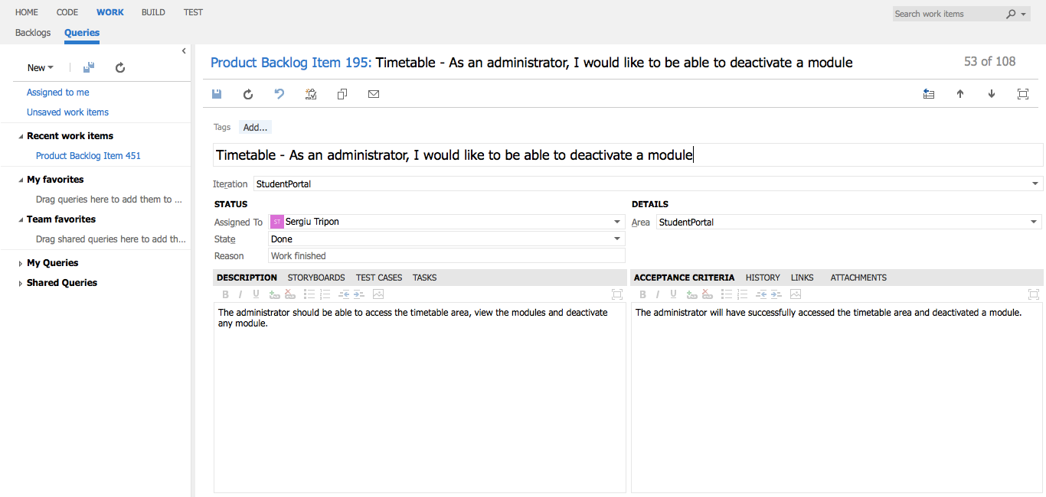

**Timetable** - detailed view of requirement

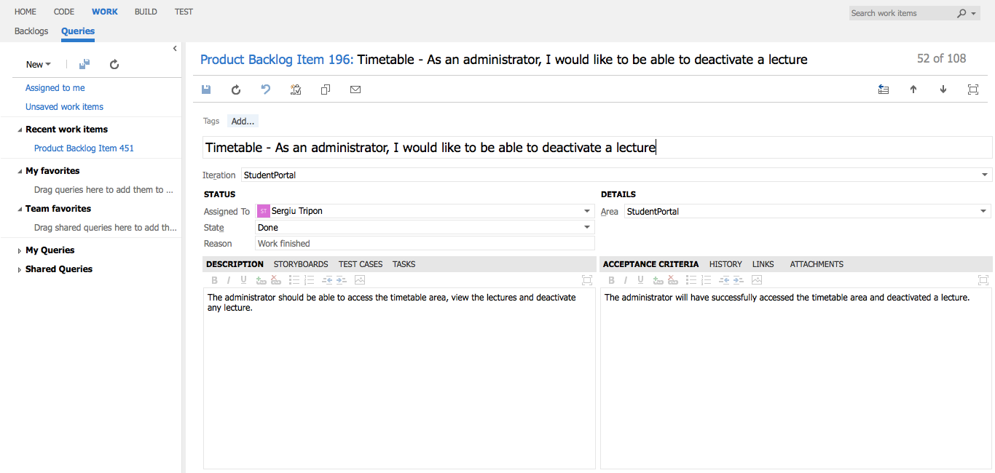

**Timetable** - detailed view of requirement

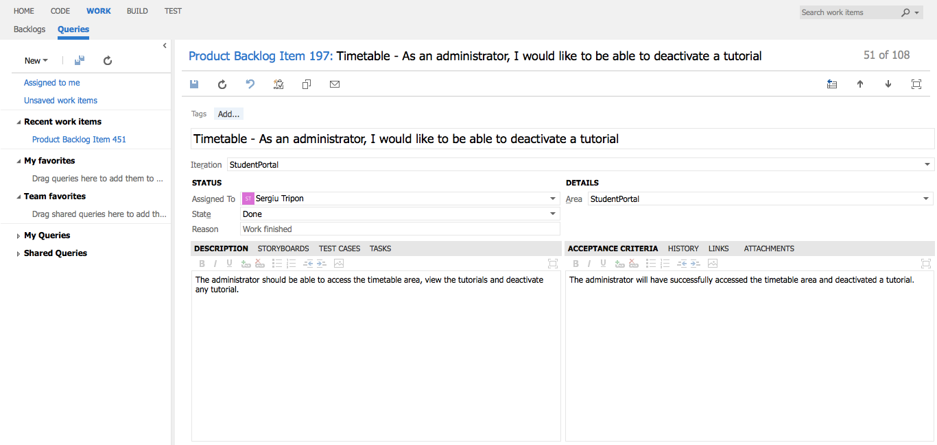

**Timetable** - detailed view of requirement

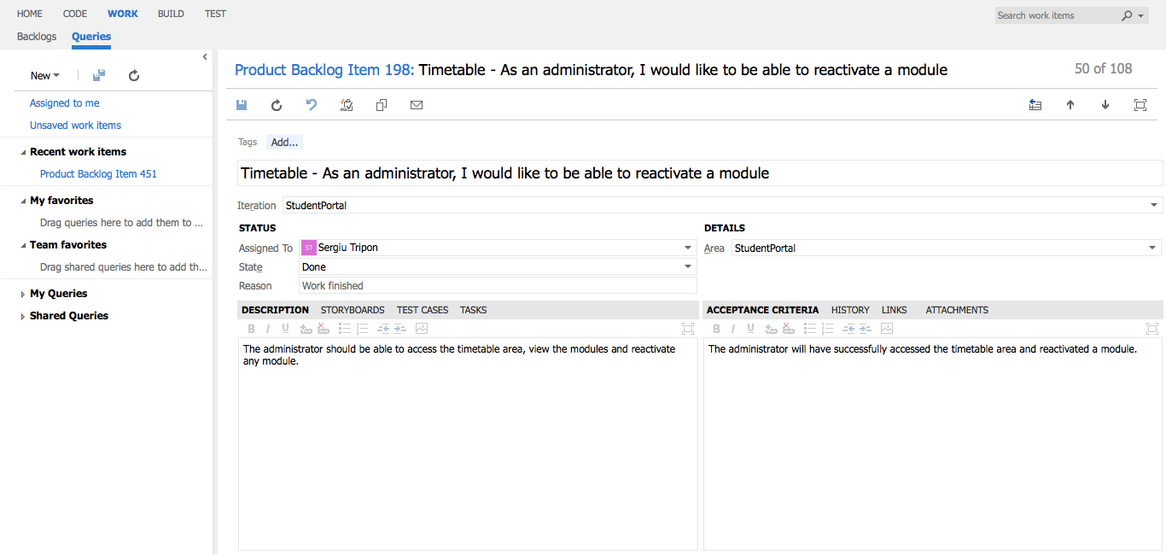

**Timetable** - detailed view of requirement

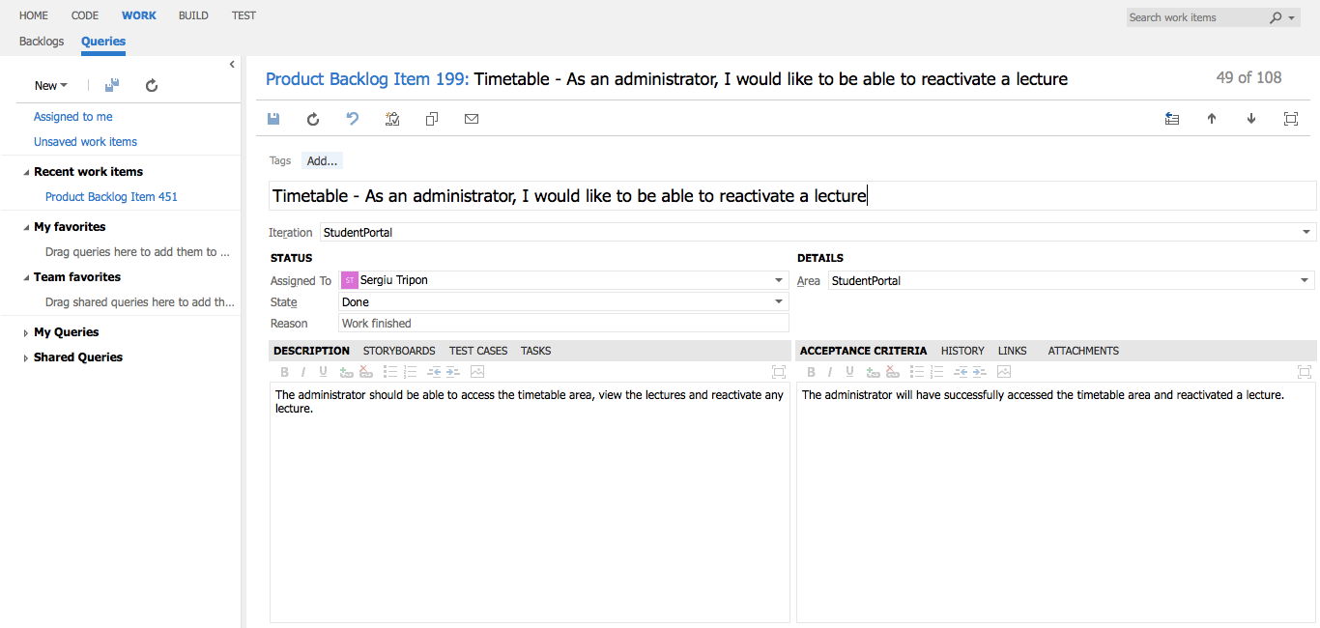

**Timetable** - detailed view of requirement

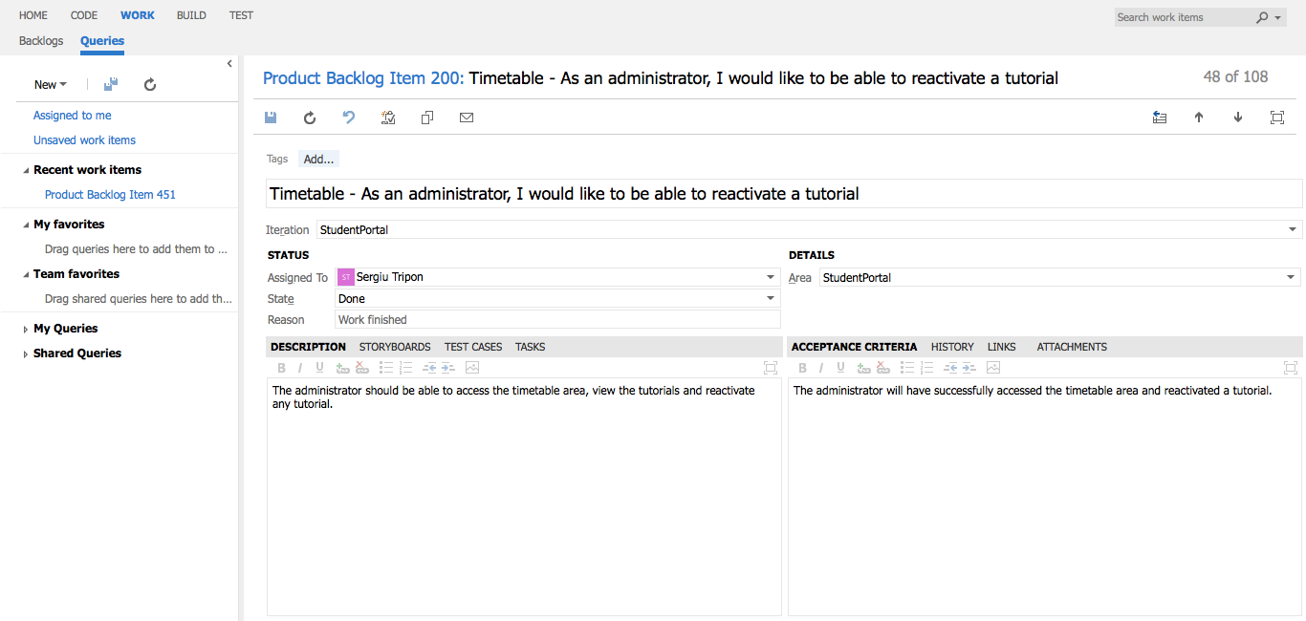

**Timetable** - detailed view of requirement

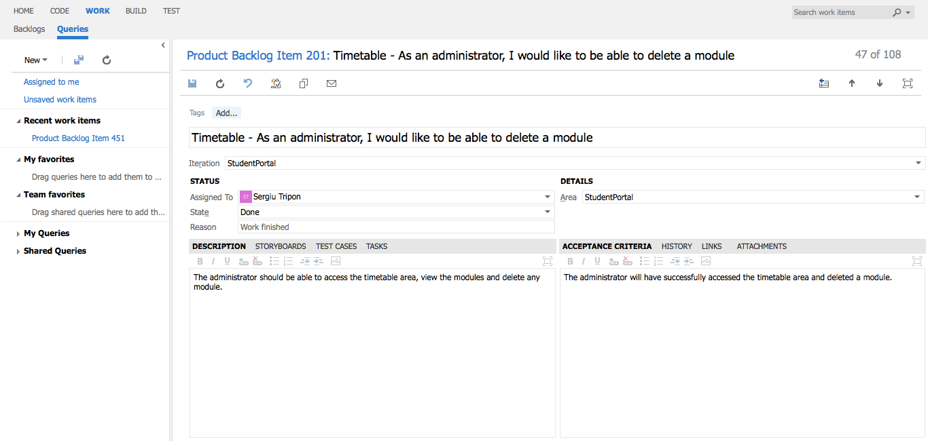

**Timetable** - detailed view of requirement

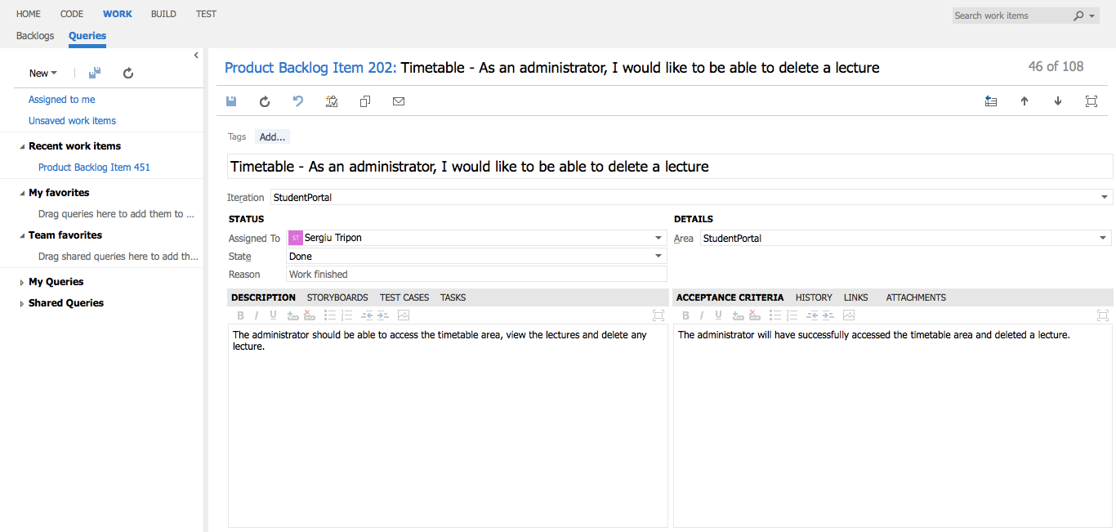

**Timetable** - detailed view of requirement

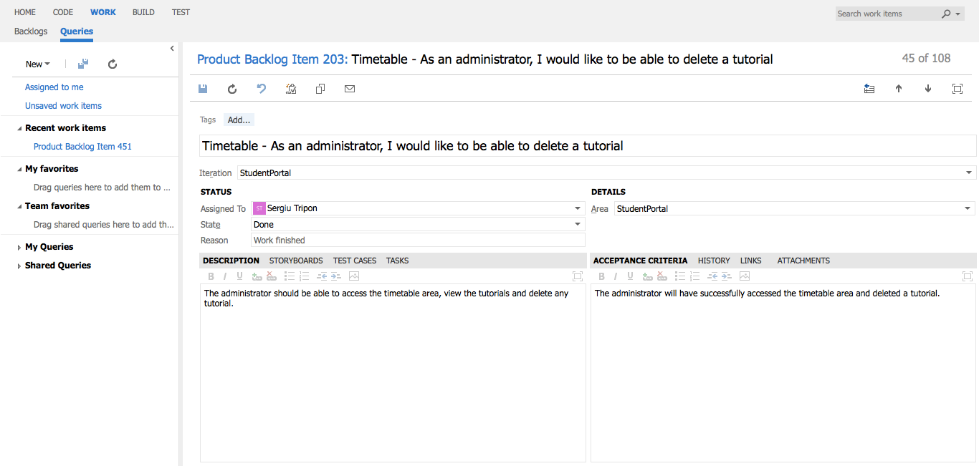

**Timetable** - detailed view of requirement

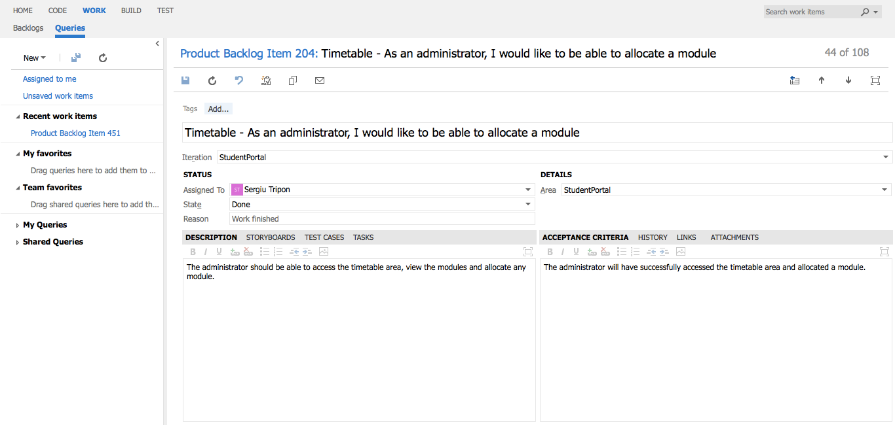

**Timetable** - detailed view of requirement

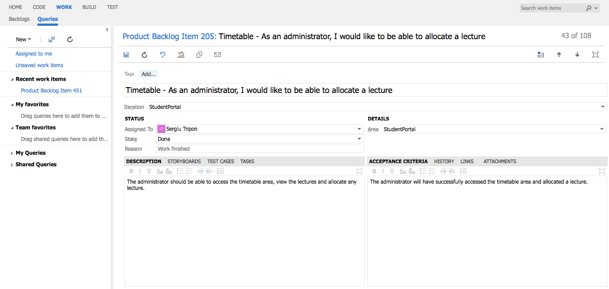

**Timetable** - detailed view of requirement

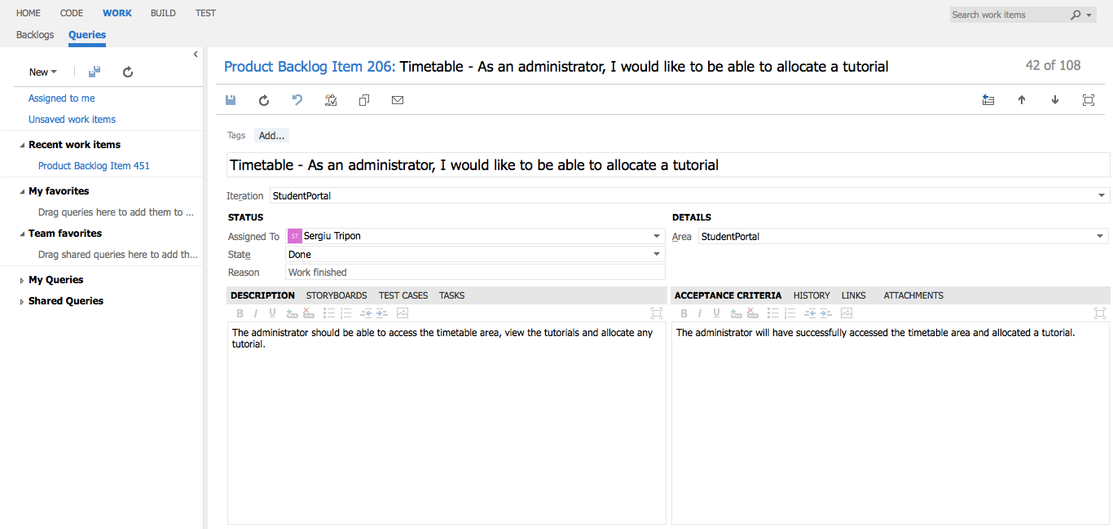

**Timetable** - detailed view of requirement

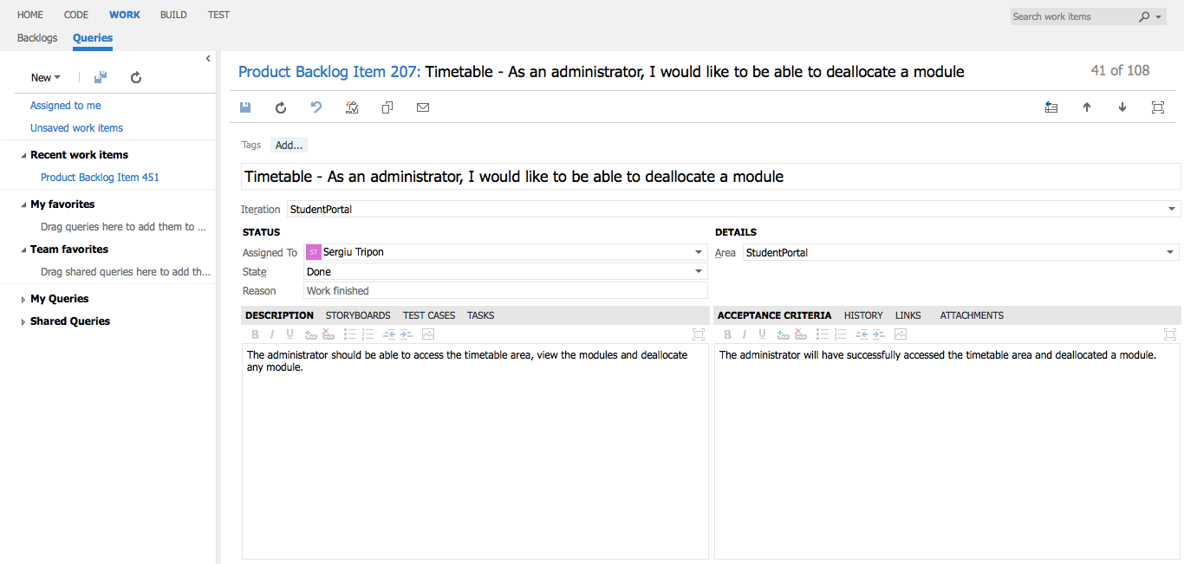

**Timetable** - detailed view of requirement

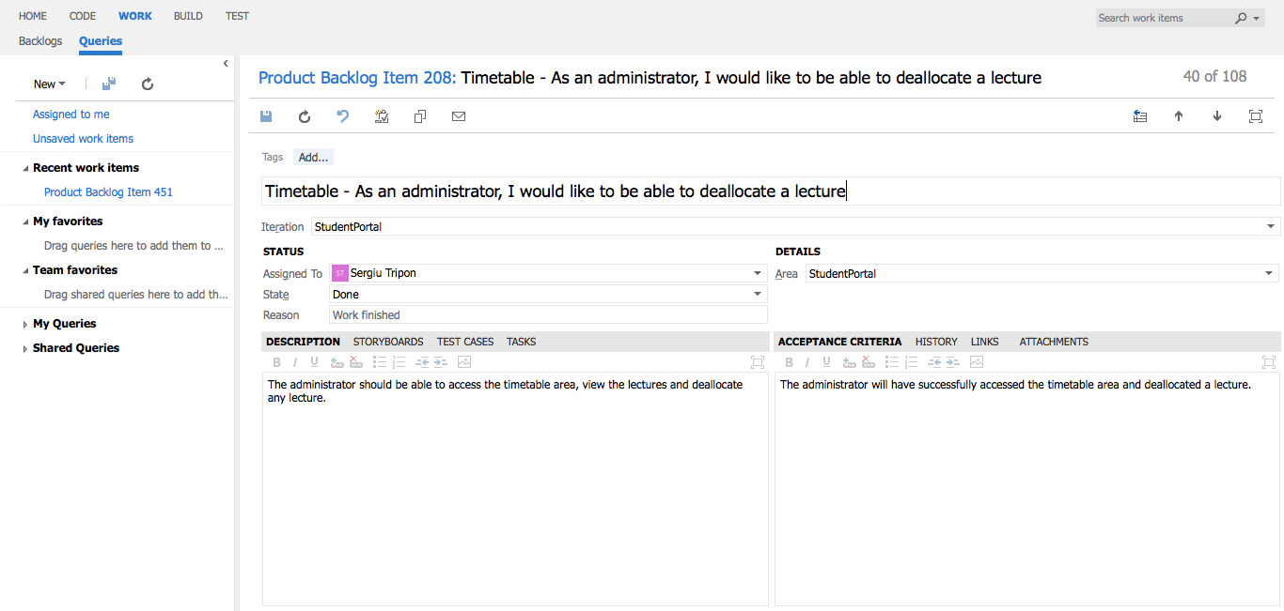

**Timetable** - detailed view of requirement

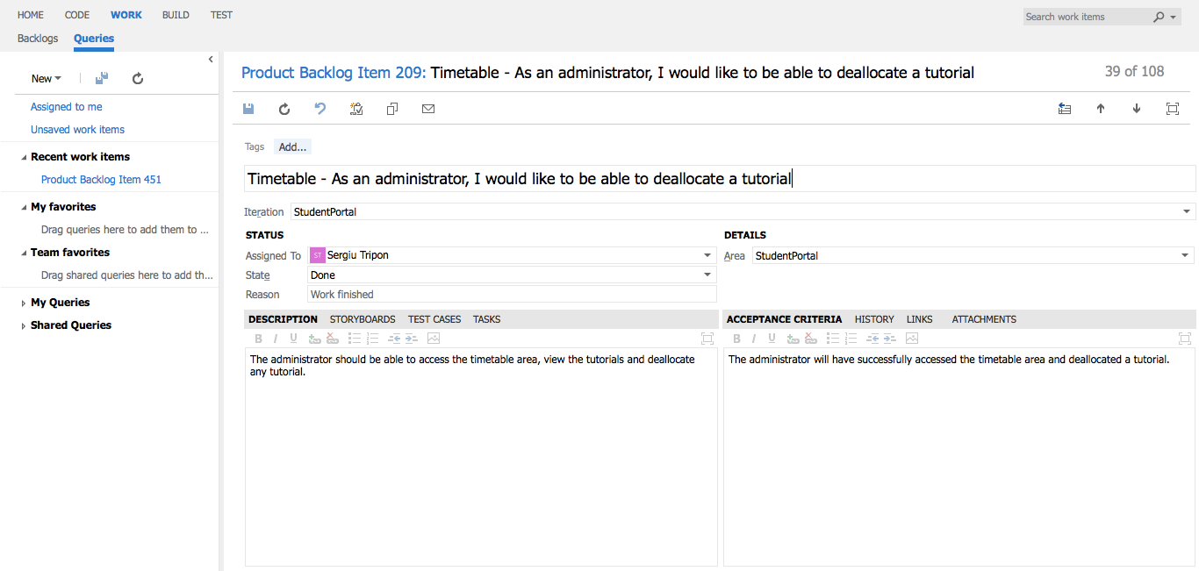

**Timetable** - detailed view of requirement

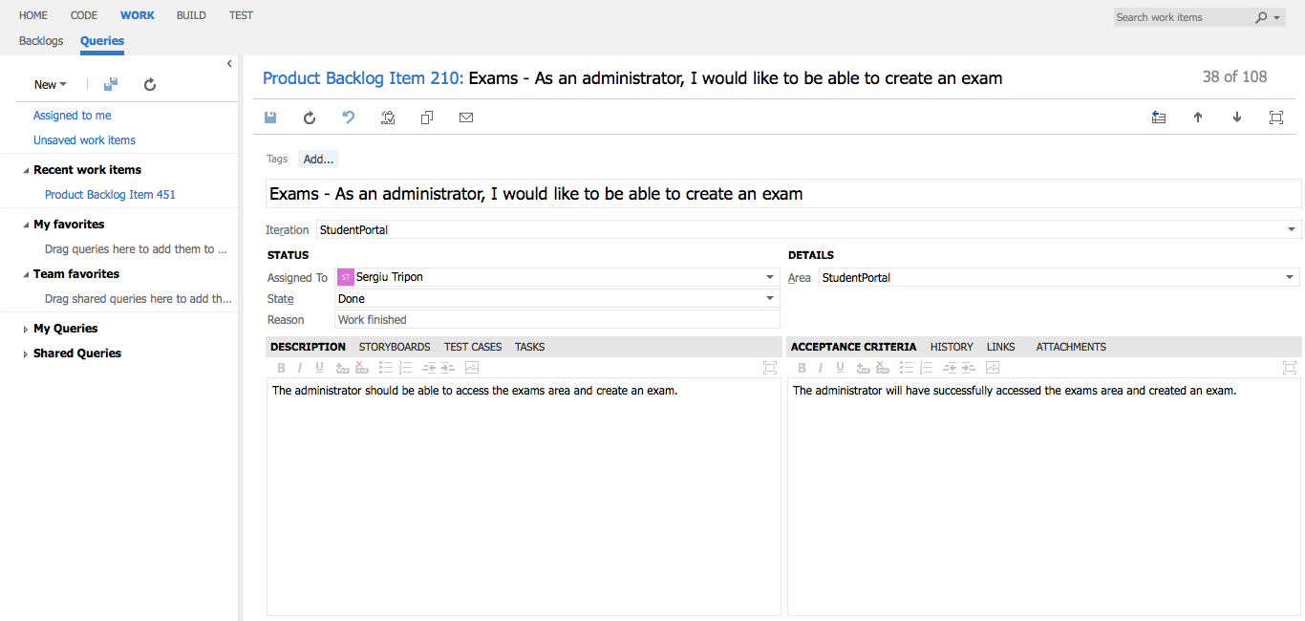

**Exams** - detailed view of requirement

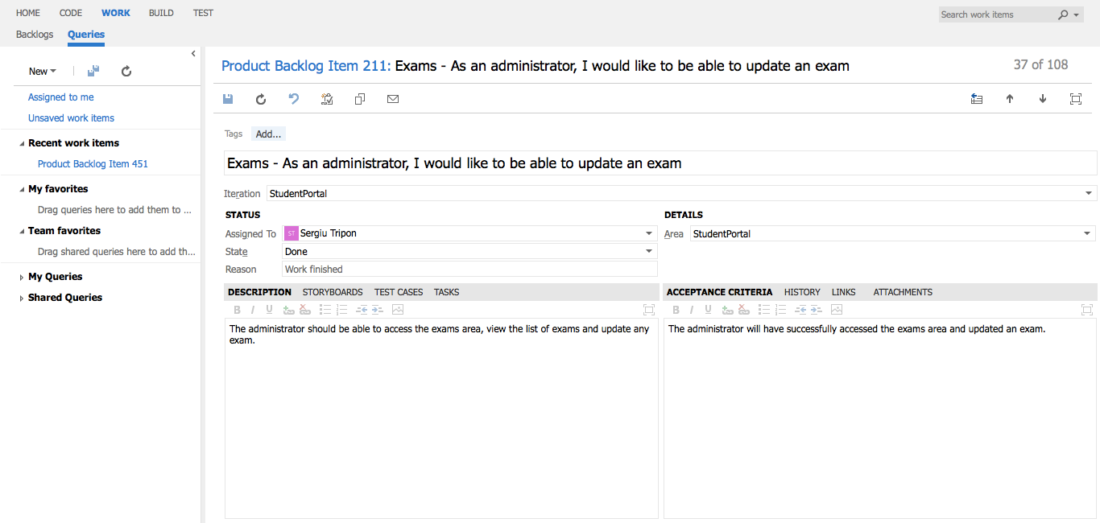

**Exams** - detailed view of requirement

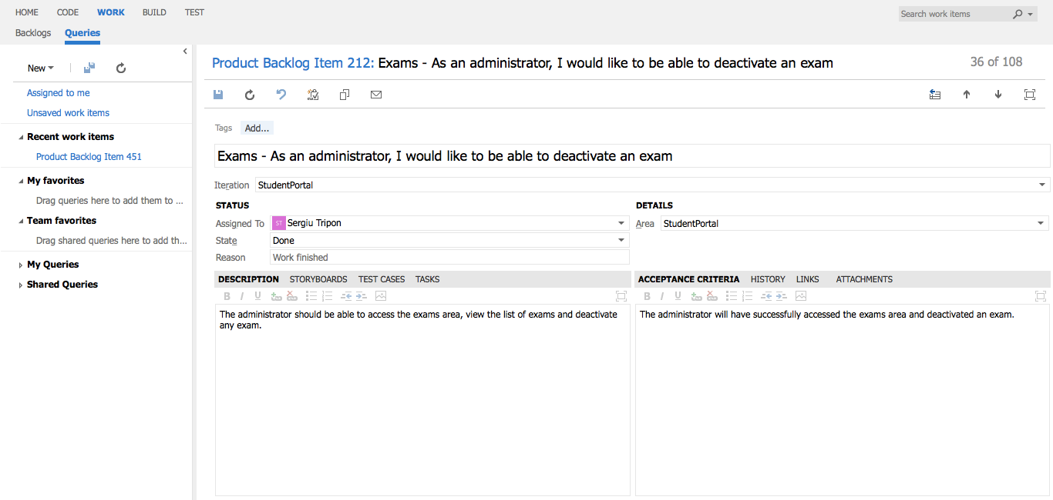

**Exams** - detailed view of requirement

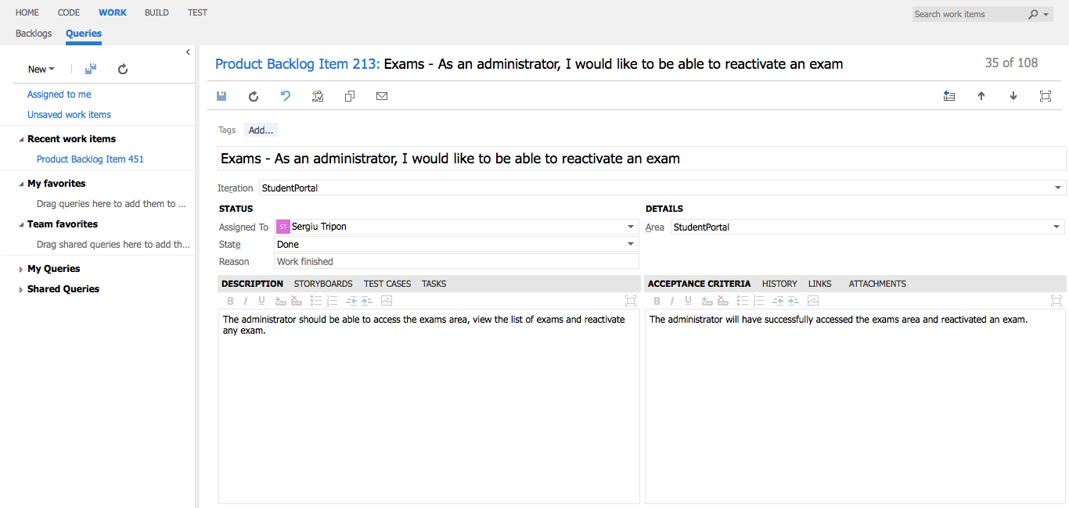

**Exams** - detailed view of requirement

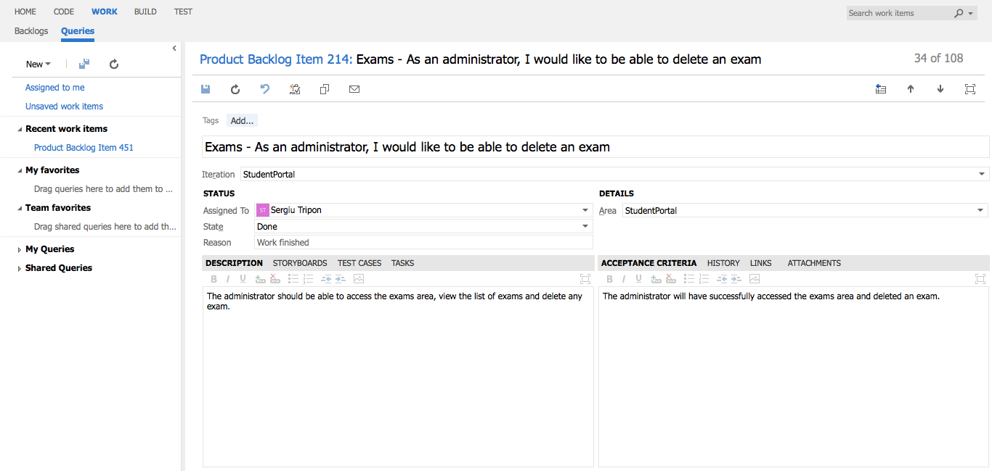

**Exams** - detailed view of requirement

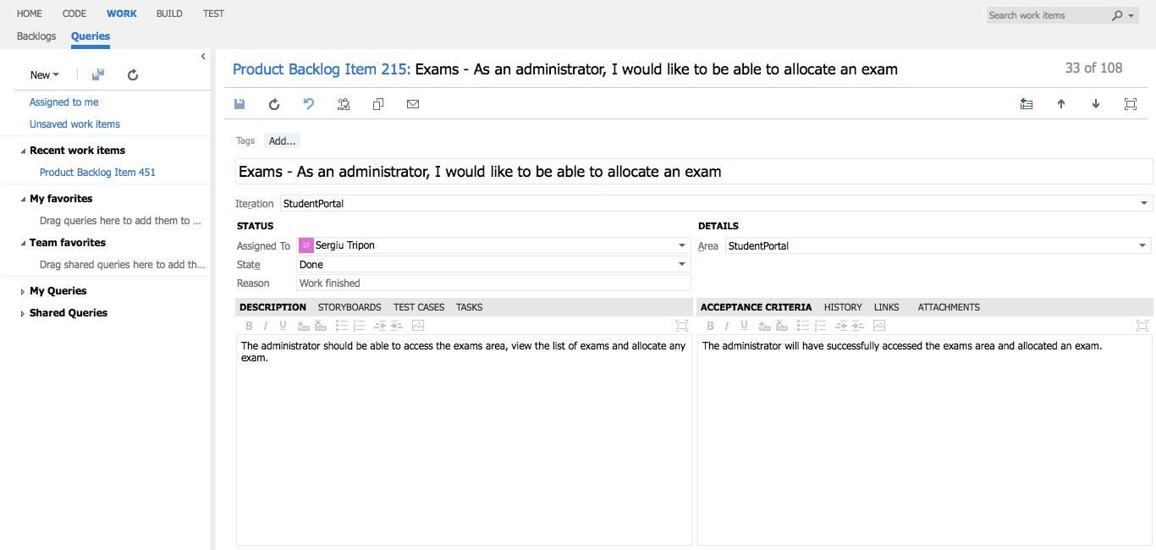

**Exams** - detailed view of requirement

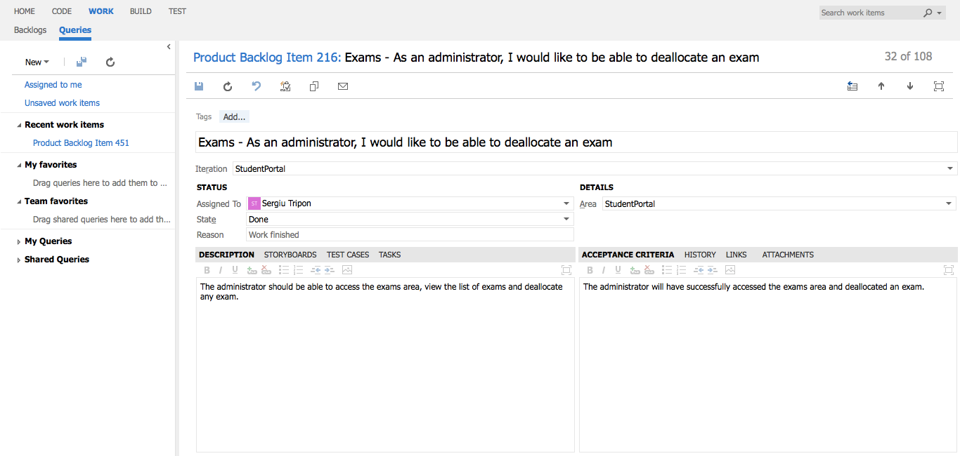

**Exams** - detailed view of requirement

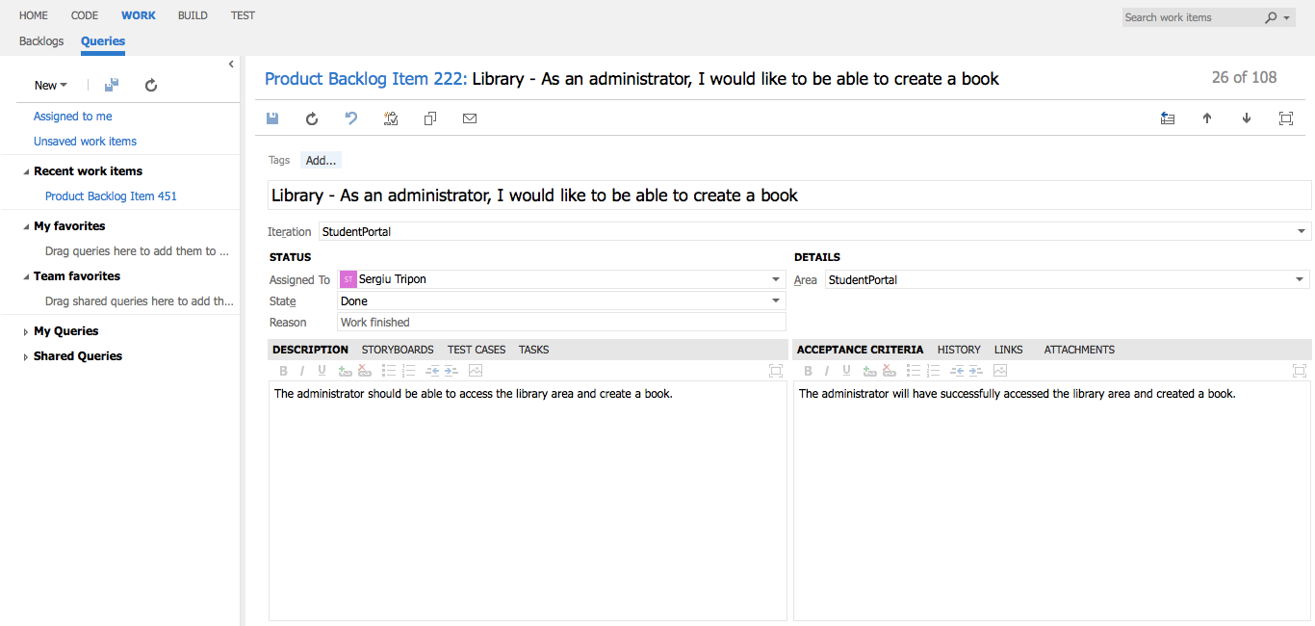

**Library** - detailed view of requirement

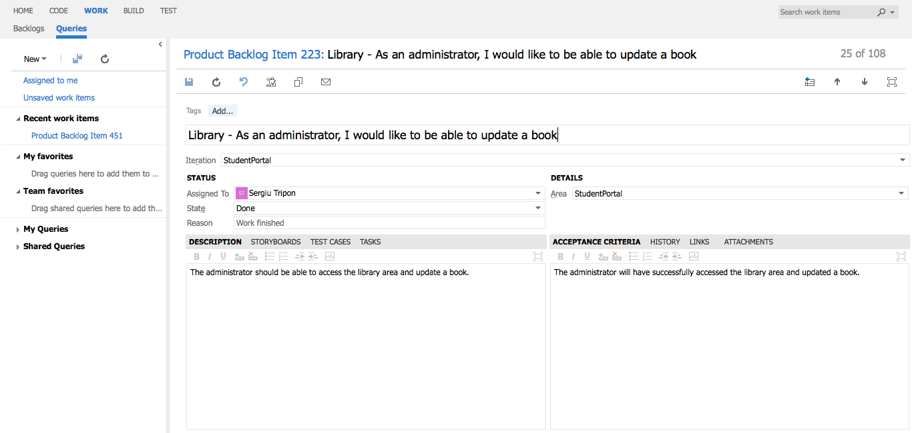

**Library** - detailed view of requirement

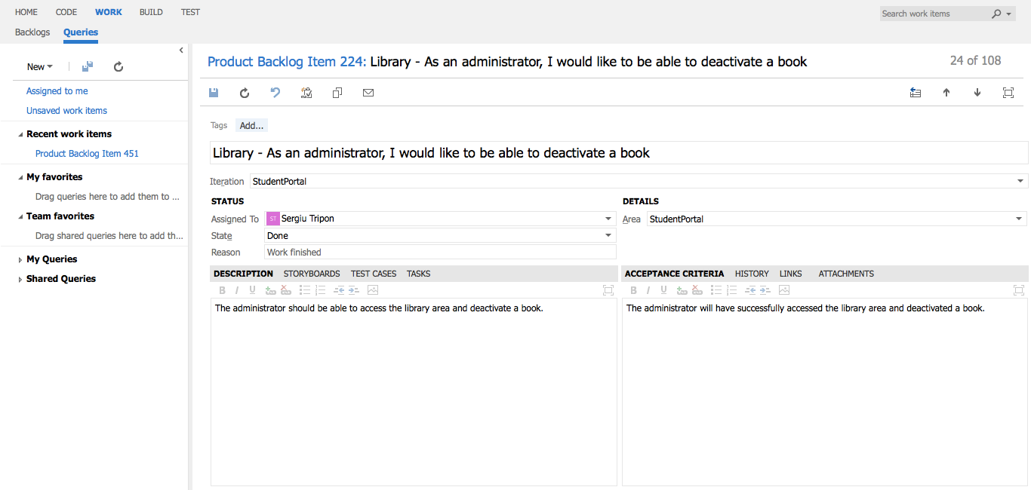

**Library** - detailed view of requirement

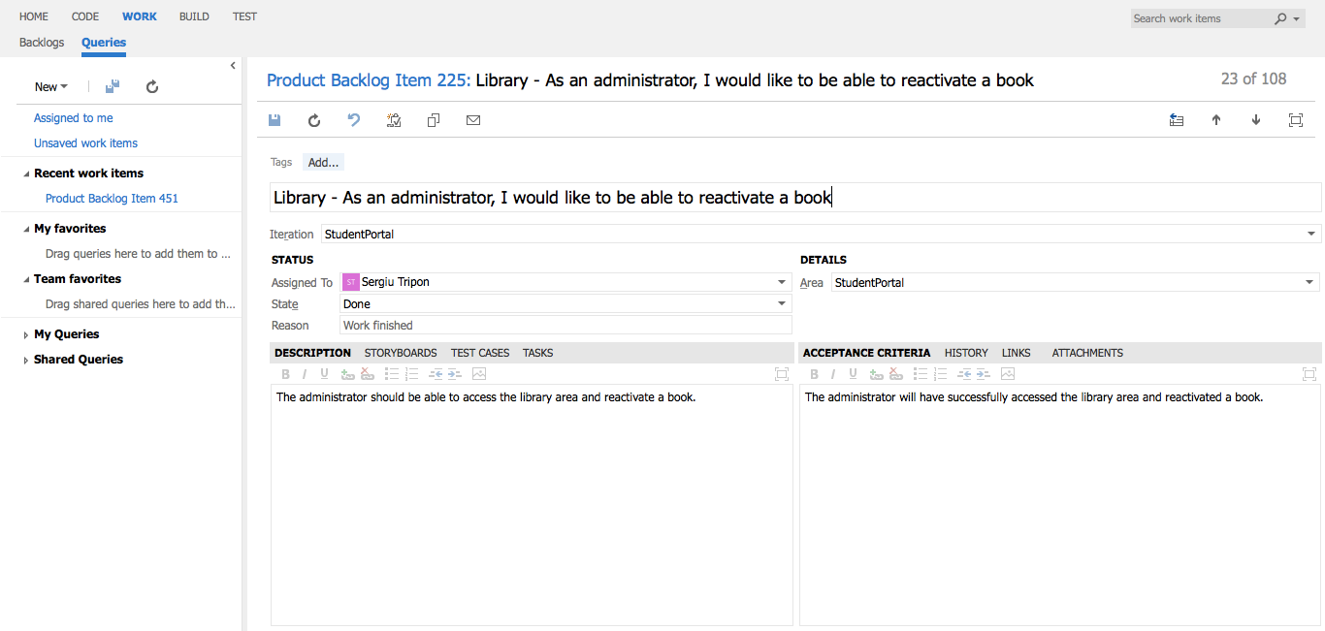

**Library** - detailed view of requirement

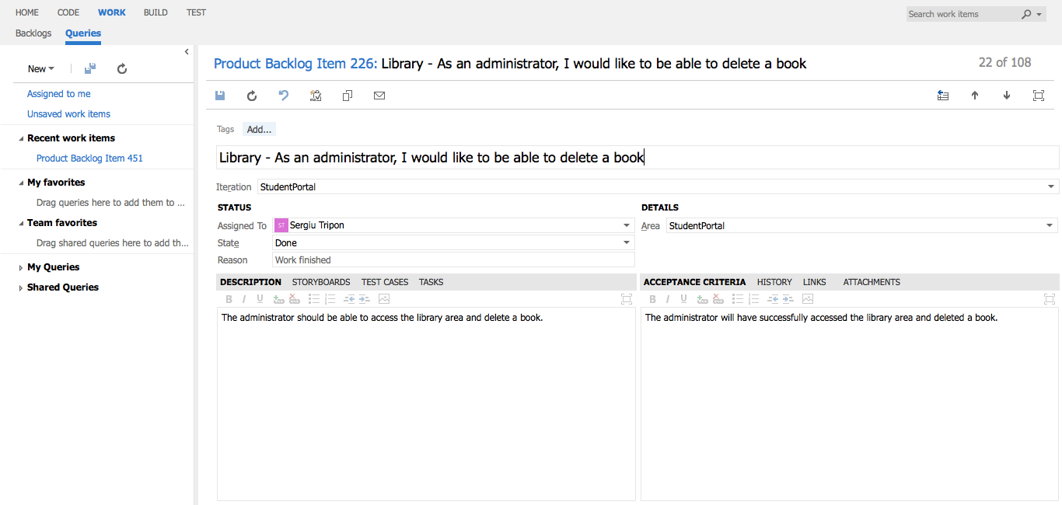

**Library** - detailed view of requirement

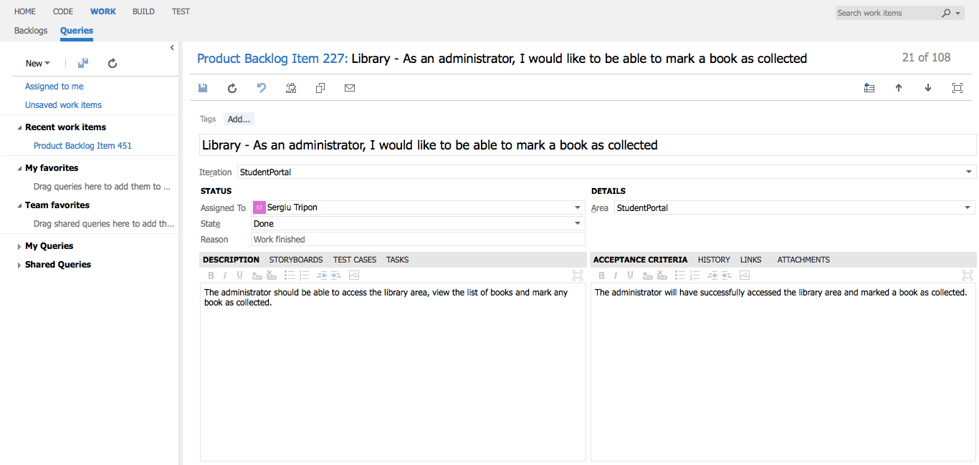

**Library** - detailed view of requirement

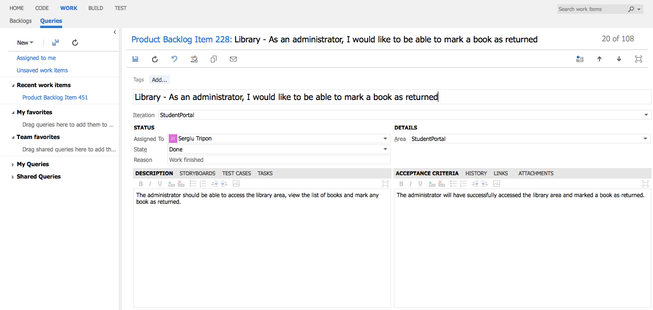

**Library** - detailed view of requirement

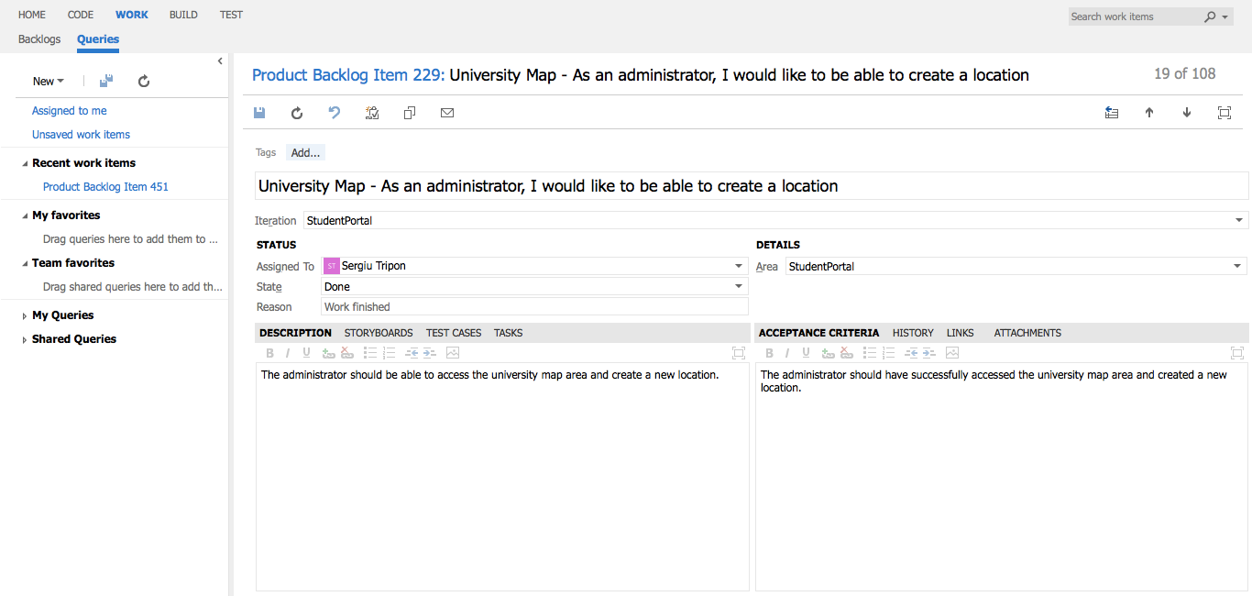

**University Map** - detailed view of requirement

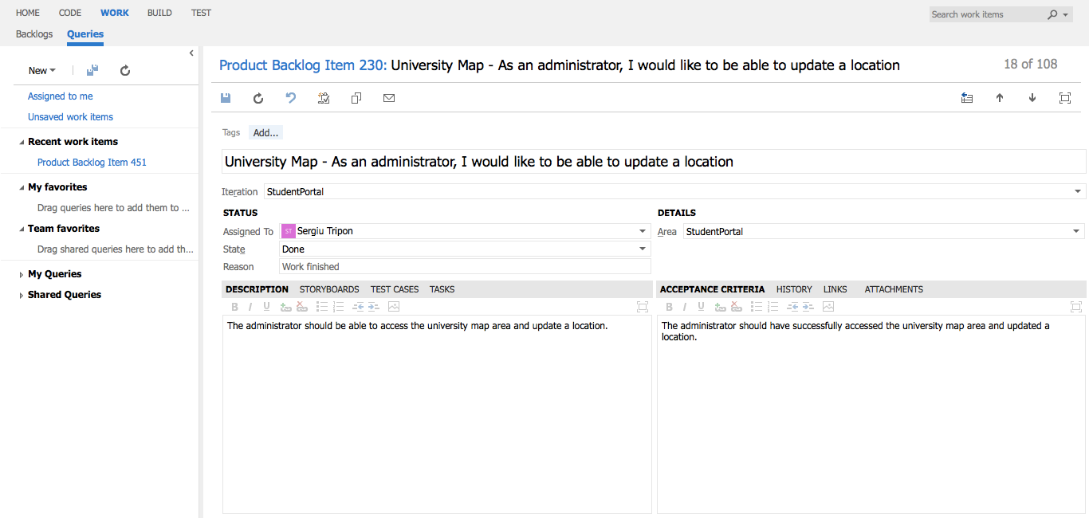

**University Map** - detailed view of requirement

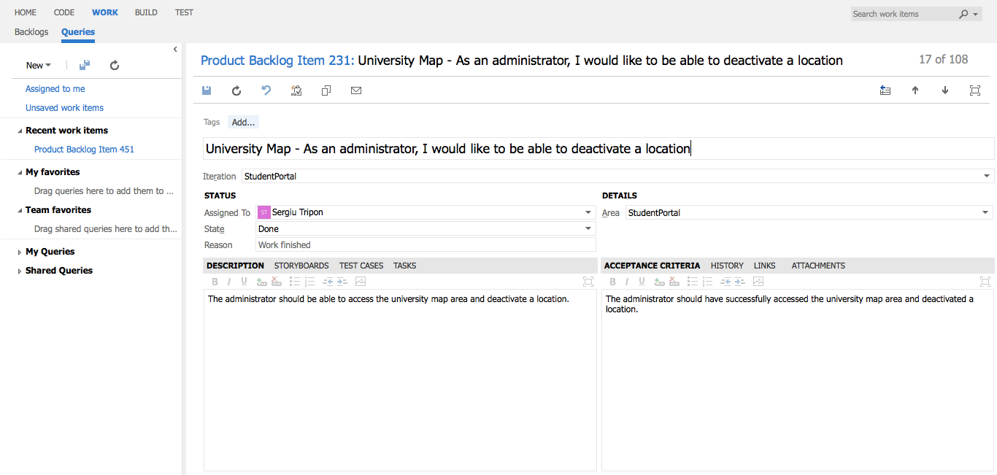

**University Map** - detailed view of requirement

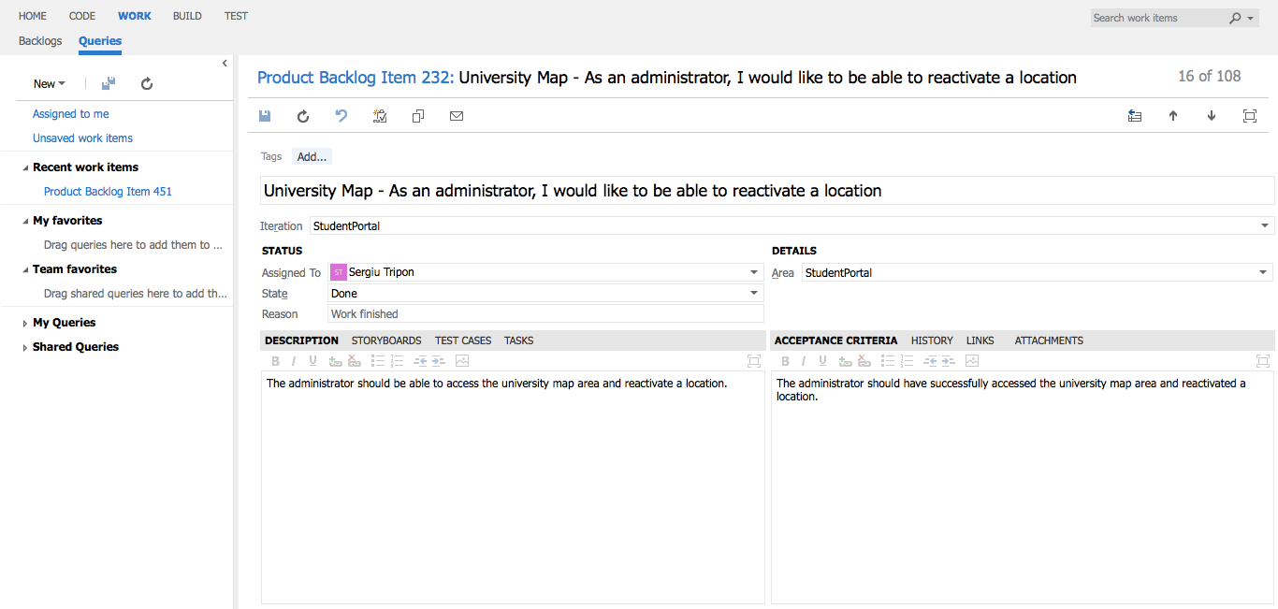

**University Map** - detailed view of requirement

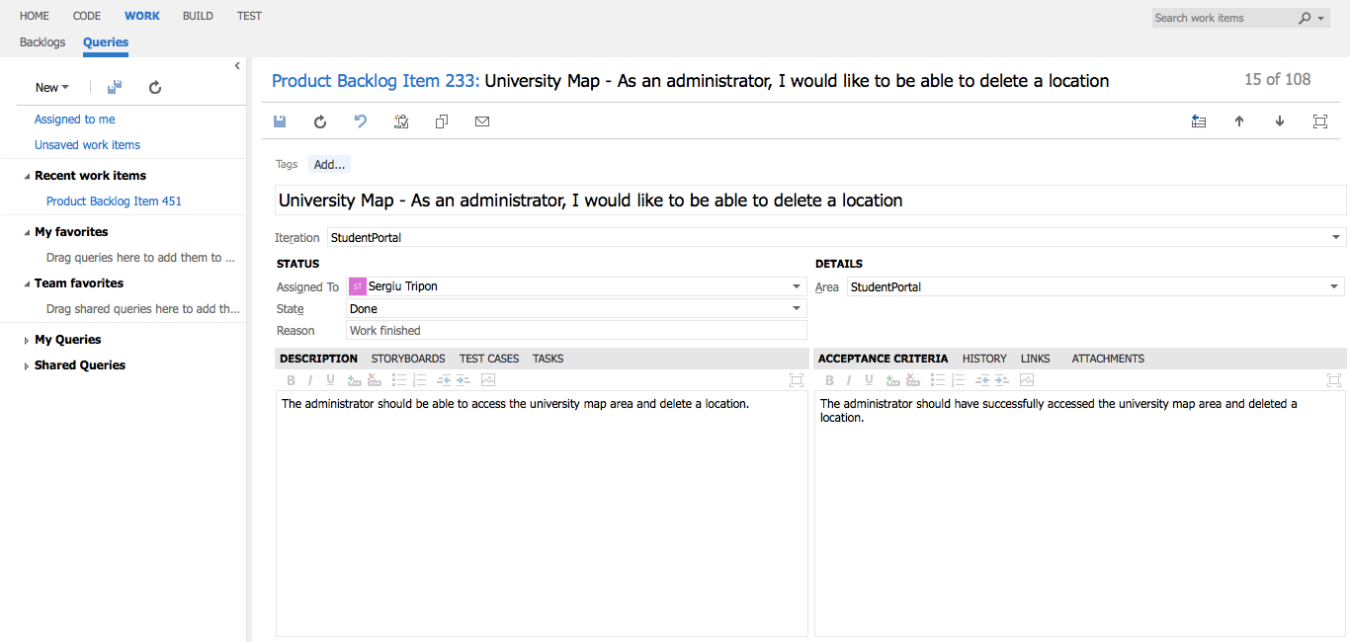

**University Map** - detailed view of requirement

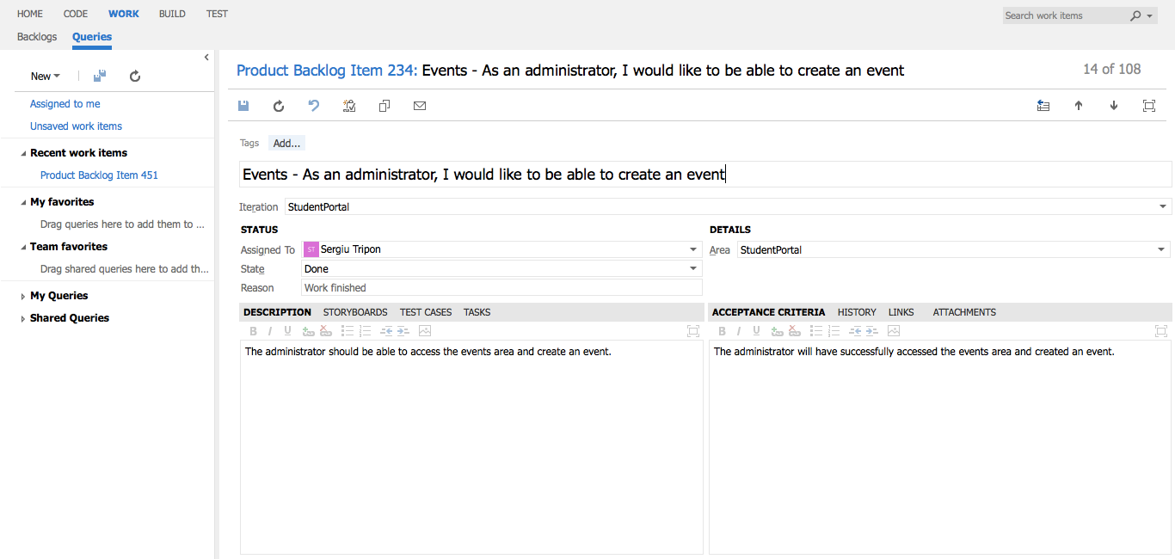

**Events** - detailed view of requirement

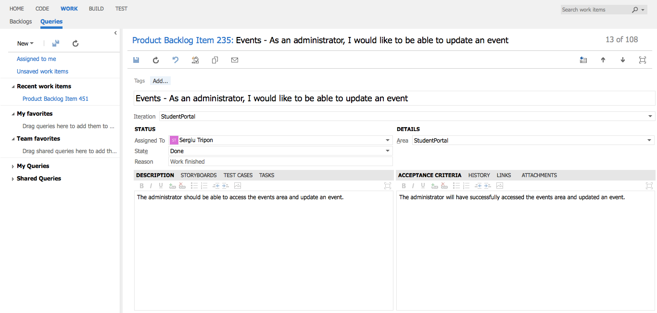

**Events** - detailed view of requirement

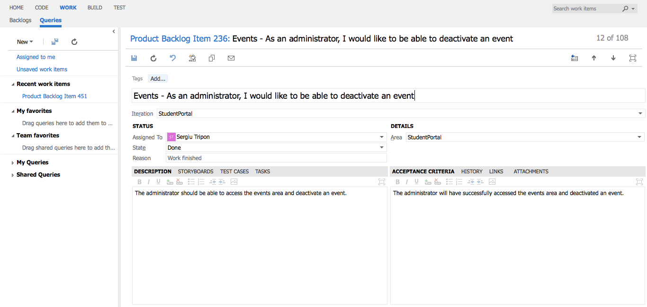

**Events** - detailed view of requirement

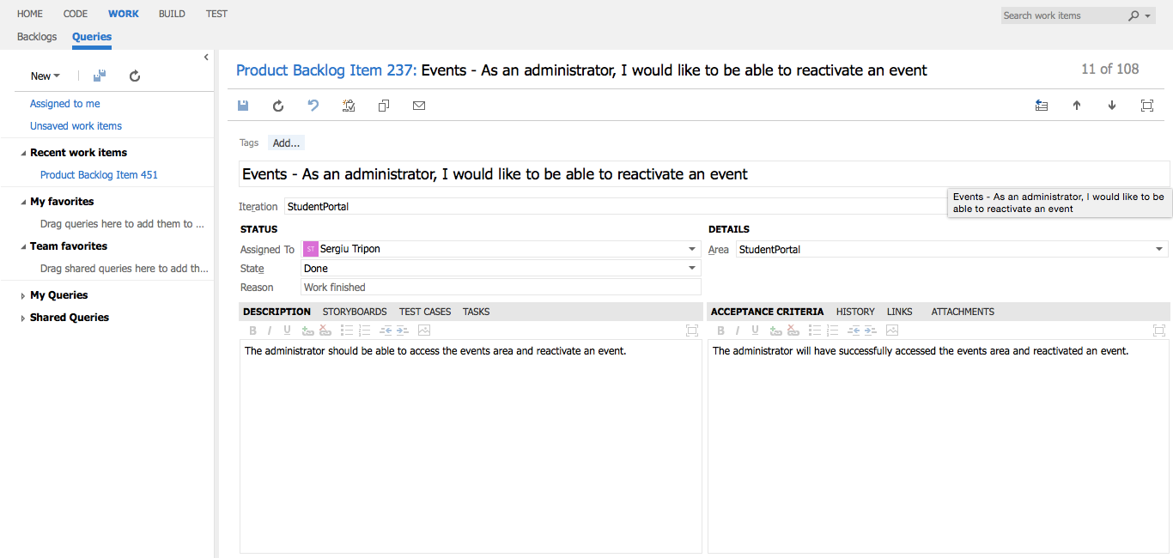

**Events** - detailed view of requirement

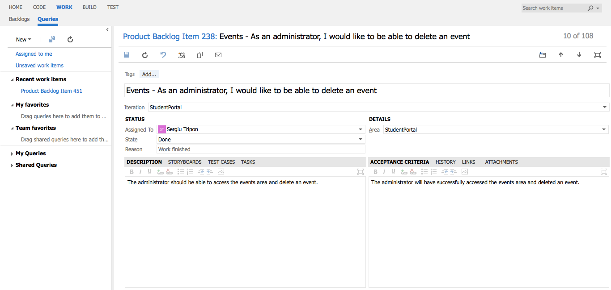

**Events** - detailed view of requirement

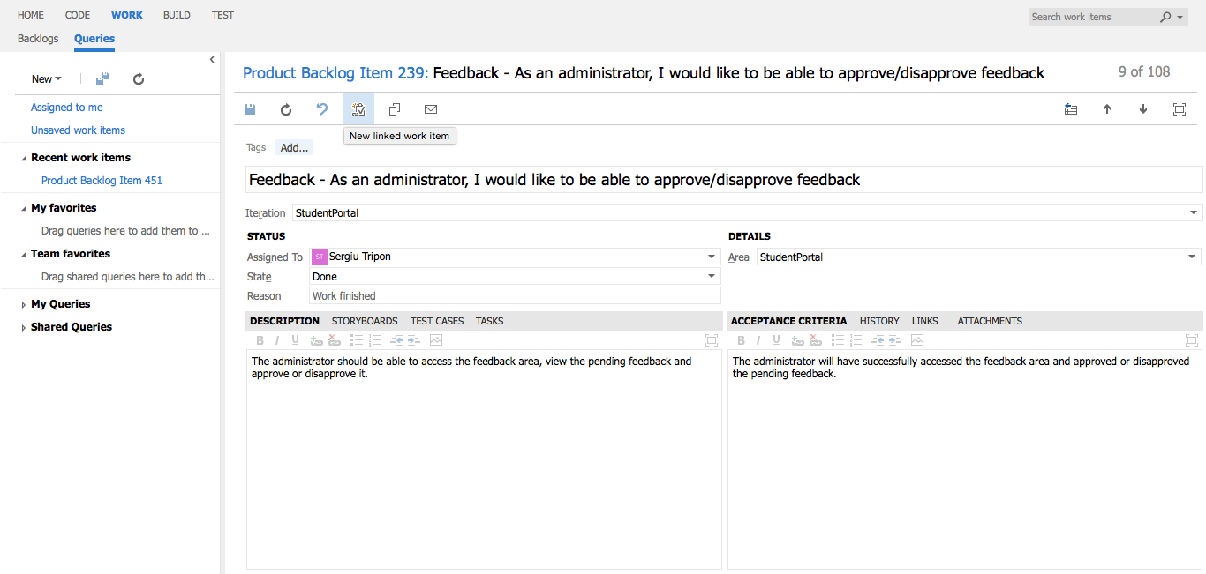

**Feedback** - detailed view of requirement

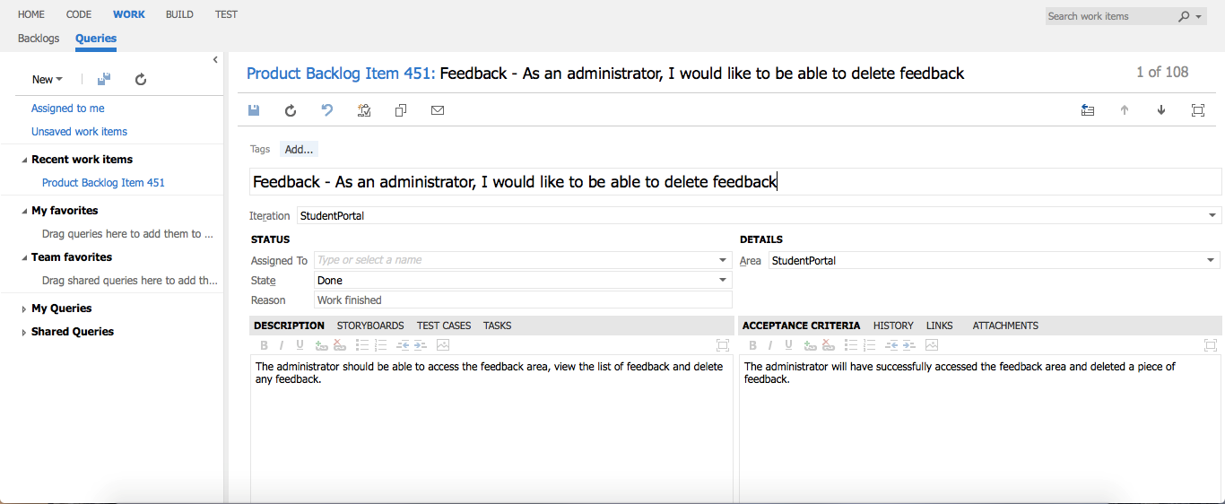

**Feedback** - detailed view of requirement

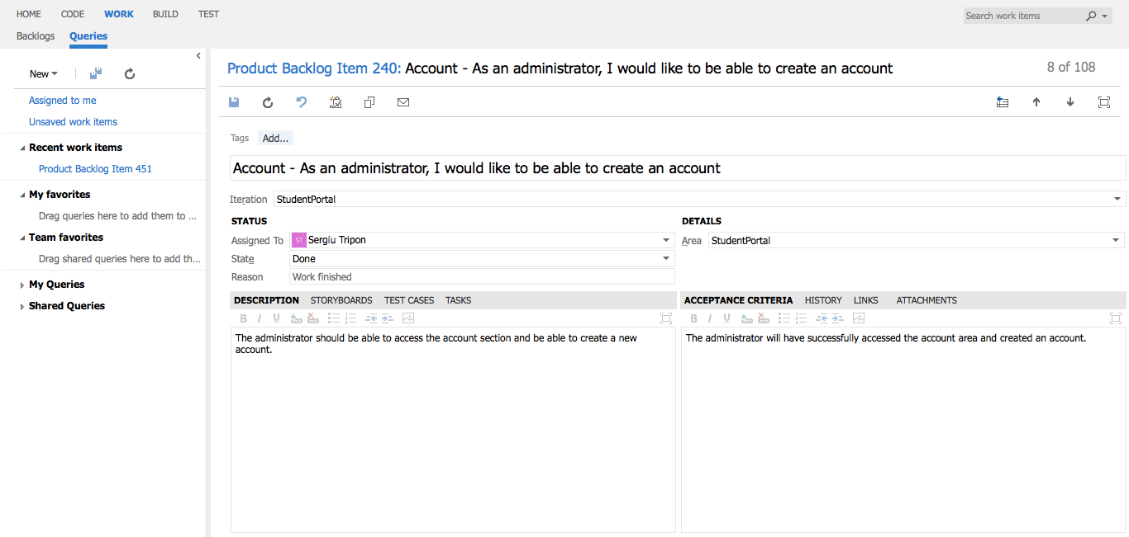

**Account** - detailed view of requirement



**Account** - detailed view of requirement

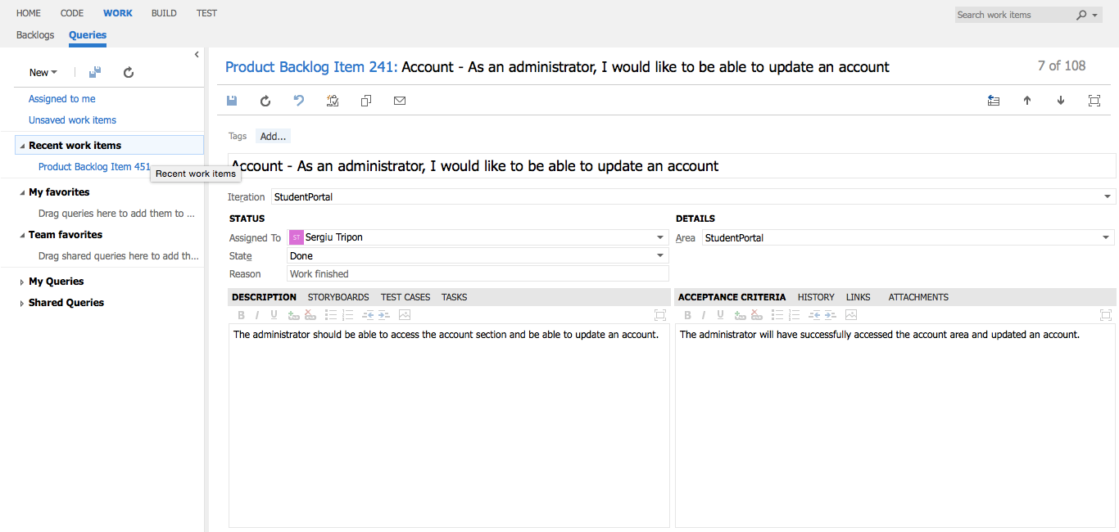

**Account** - detailed view of requirement

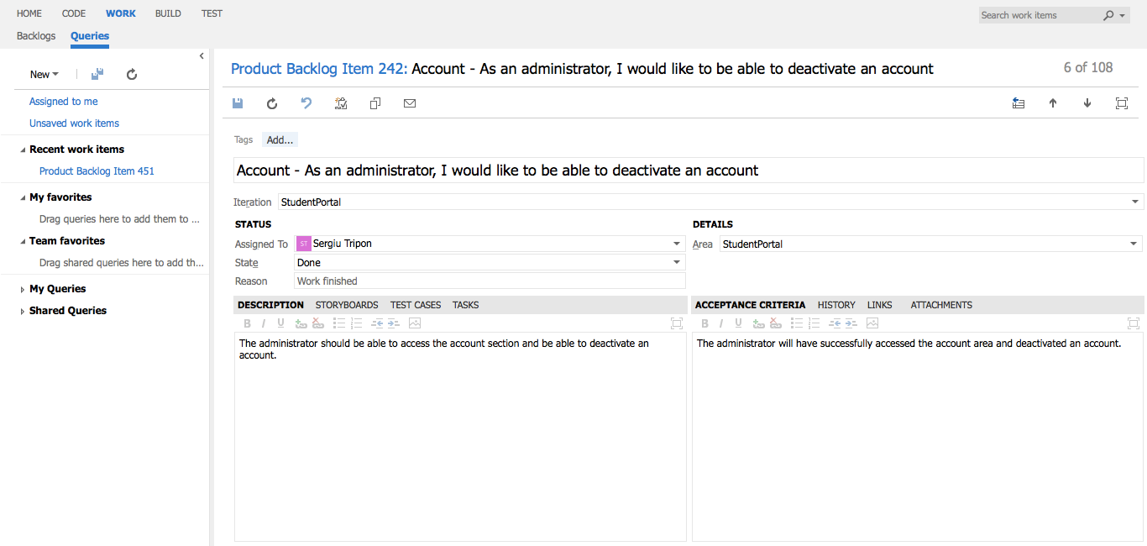

**Account** - detailed view of requirement

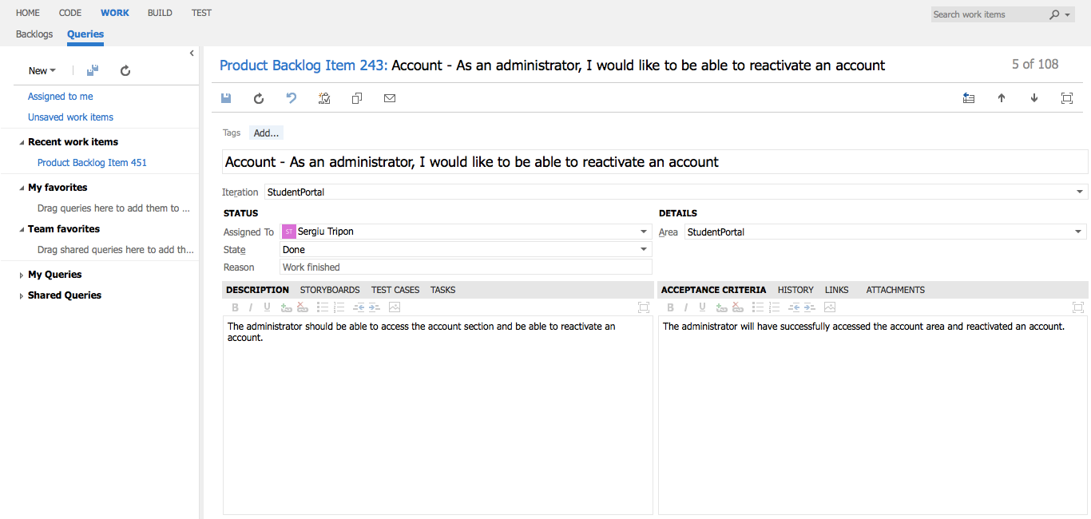

**Account** - detailed view of requirement

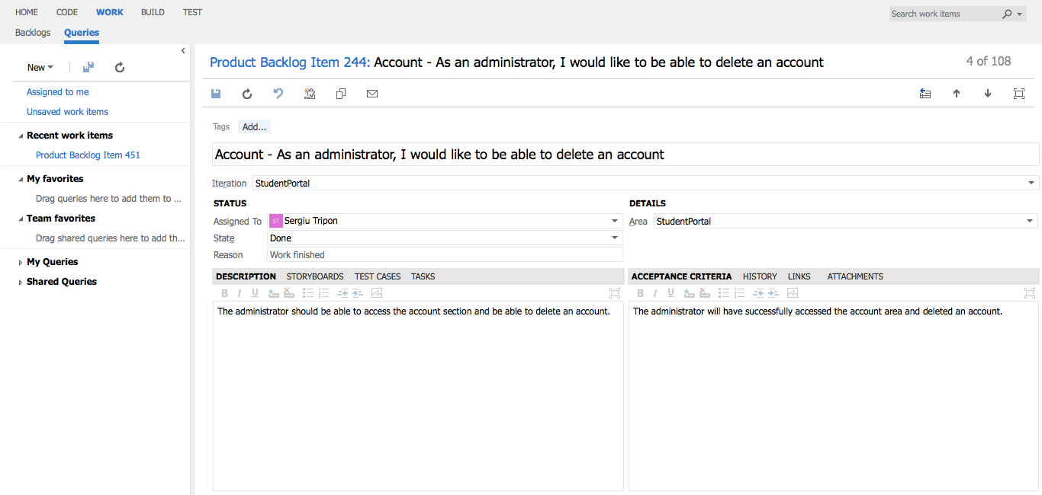

**Account** - detailed view of requirement

# Common requirements

## Student, Academic staff, Administrator

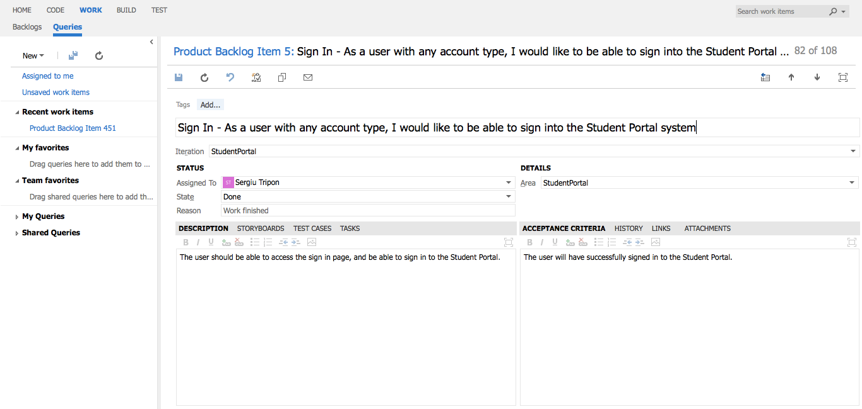

**Sign In** - detailed view of requirement

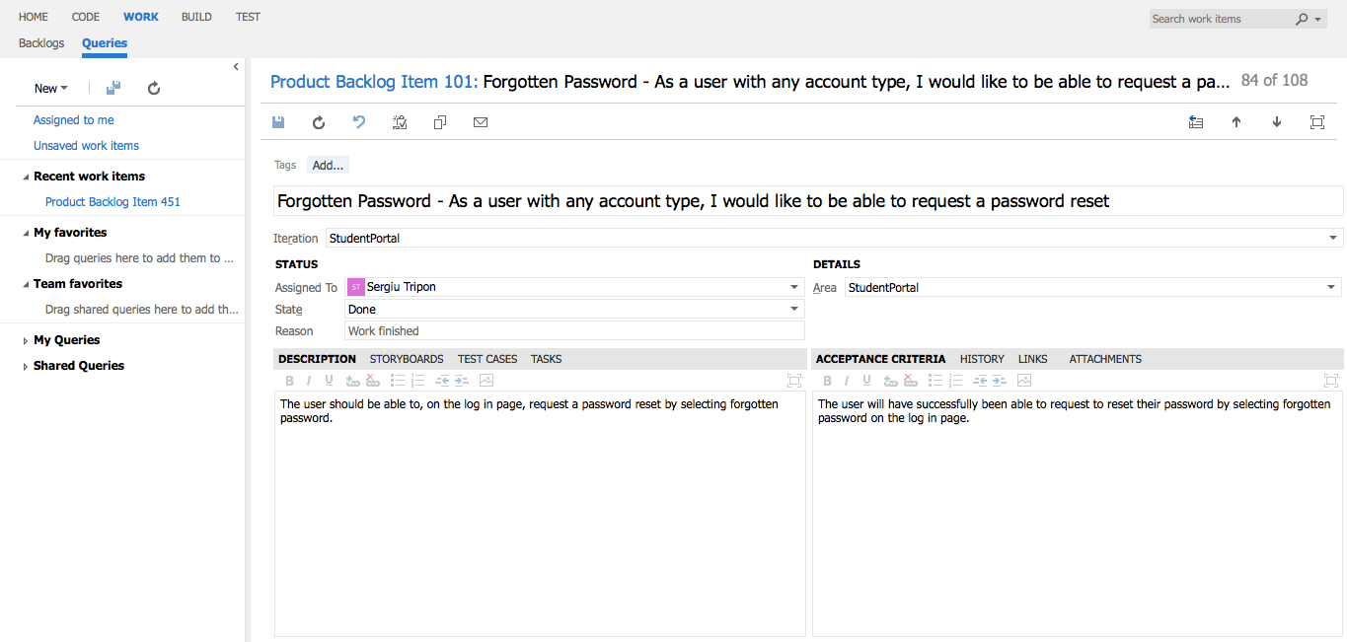

**Forgotten Password** - detailed view of requirement

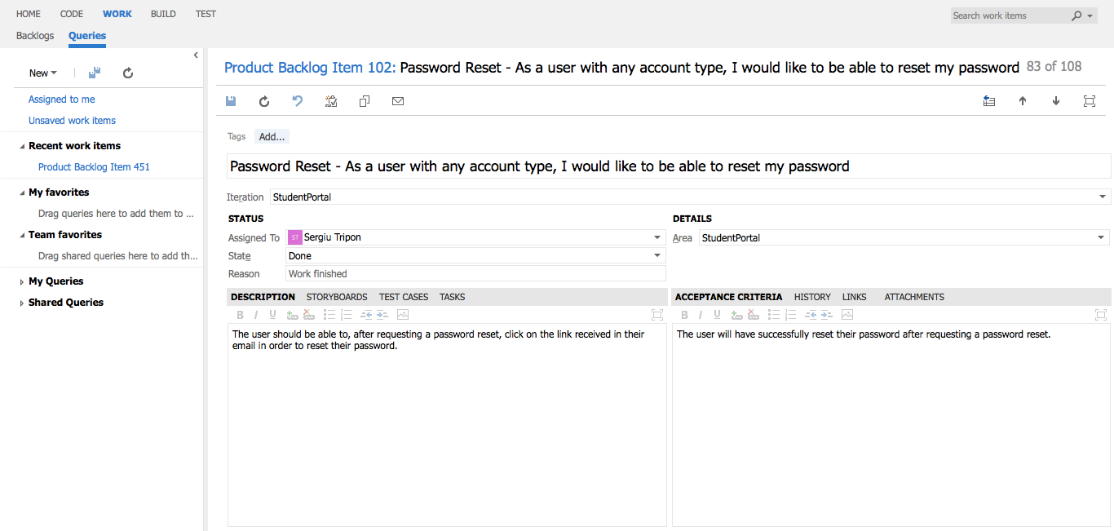

**Password Reset** - detailed view of requirement

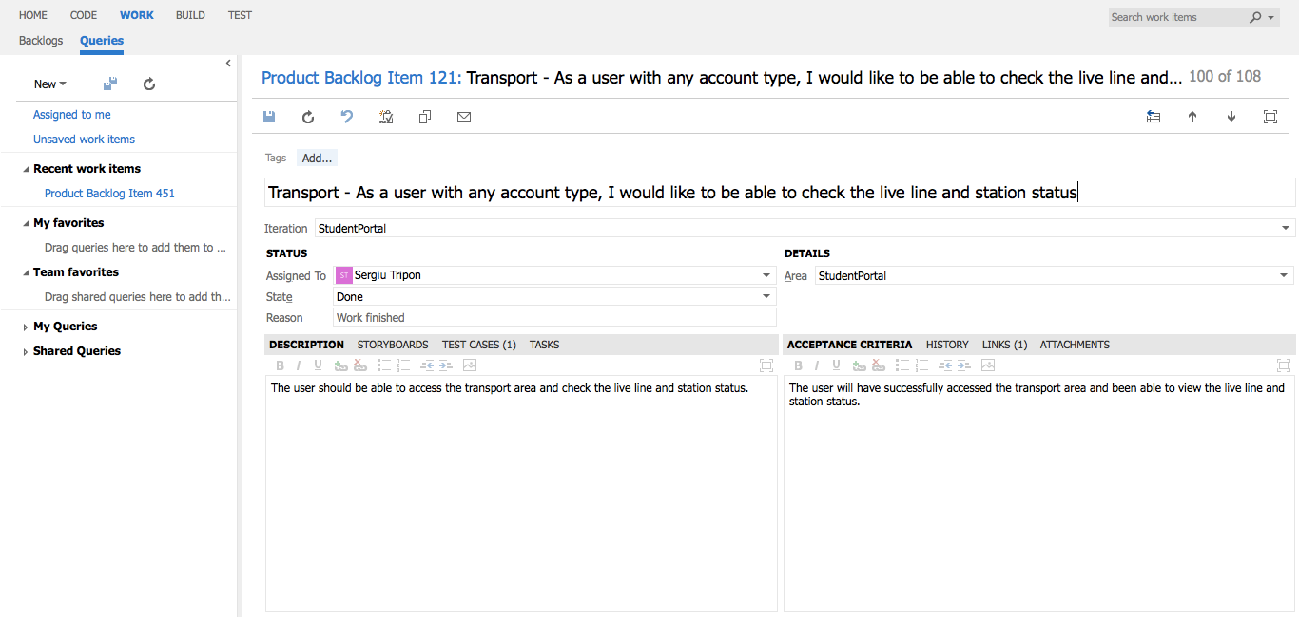

**Transport** - detailed view of requirement

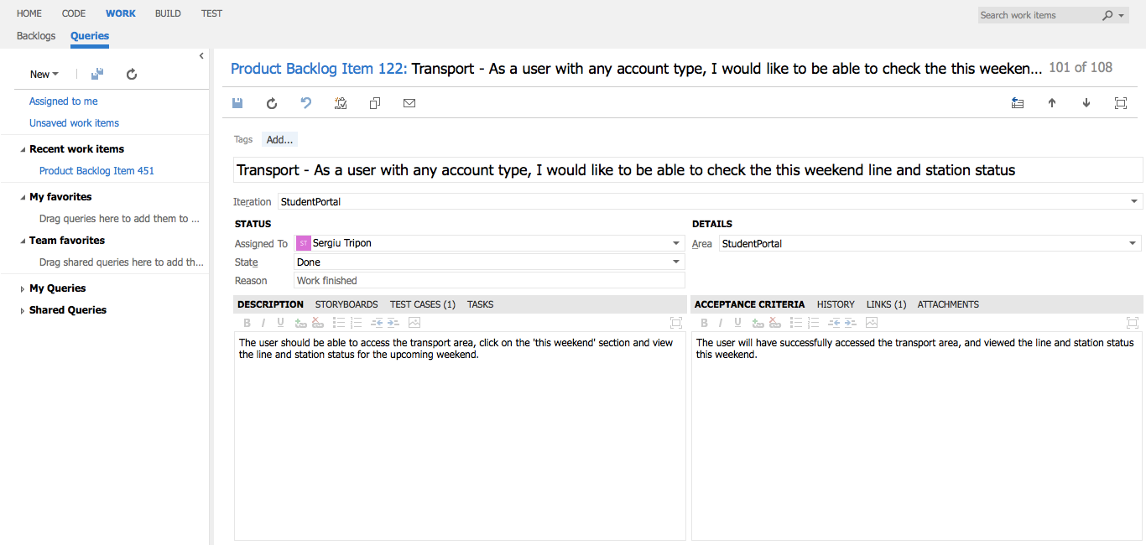

**Transport** - detailed view of requirement

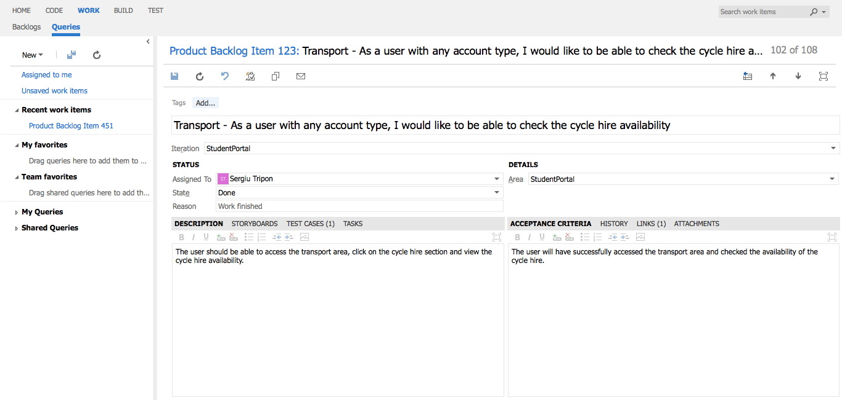

**Transport** - detailed view of requirement

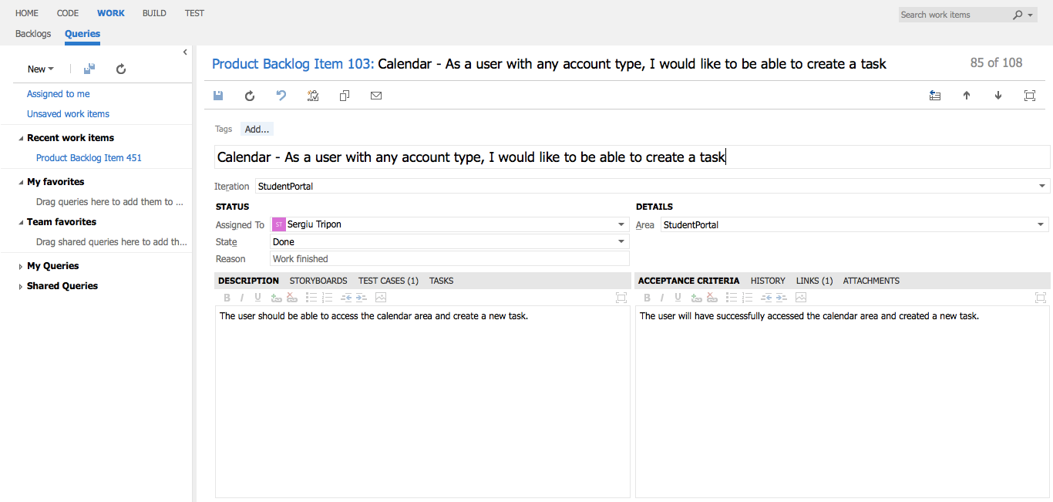

**Calendar** - detailed view of requirement

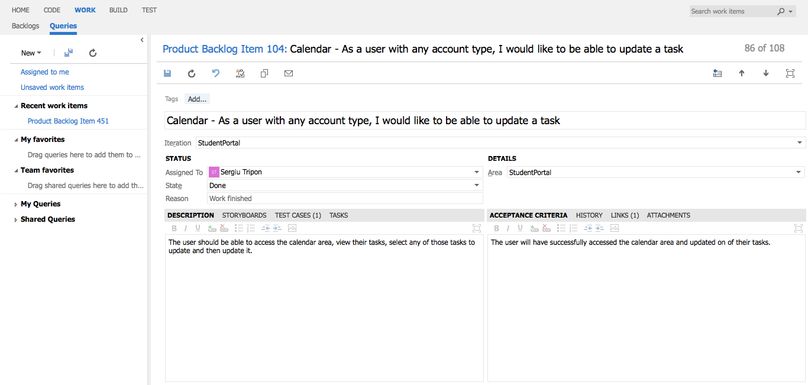

**Calendar** - detailed view of requirement

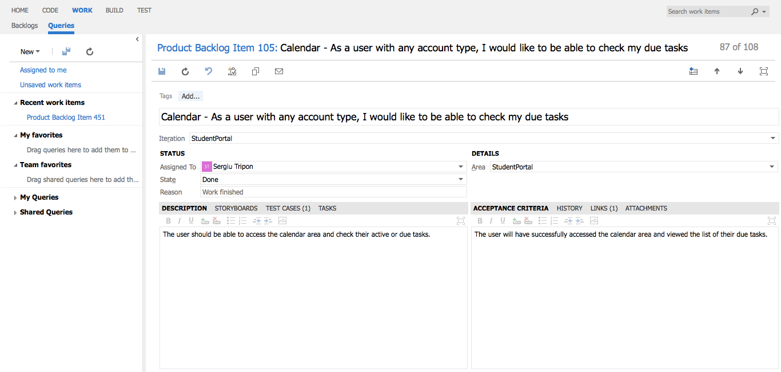

**Calendar** - detailed view of requirement

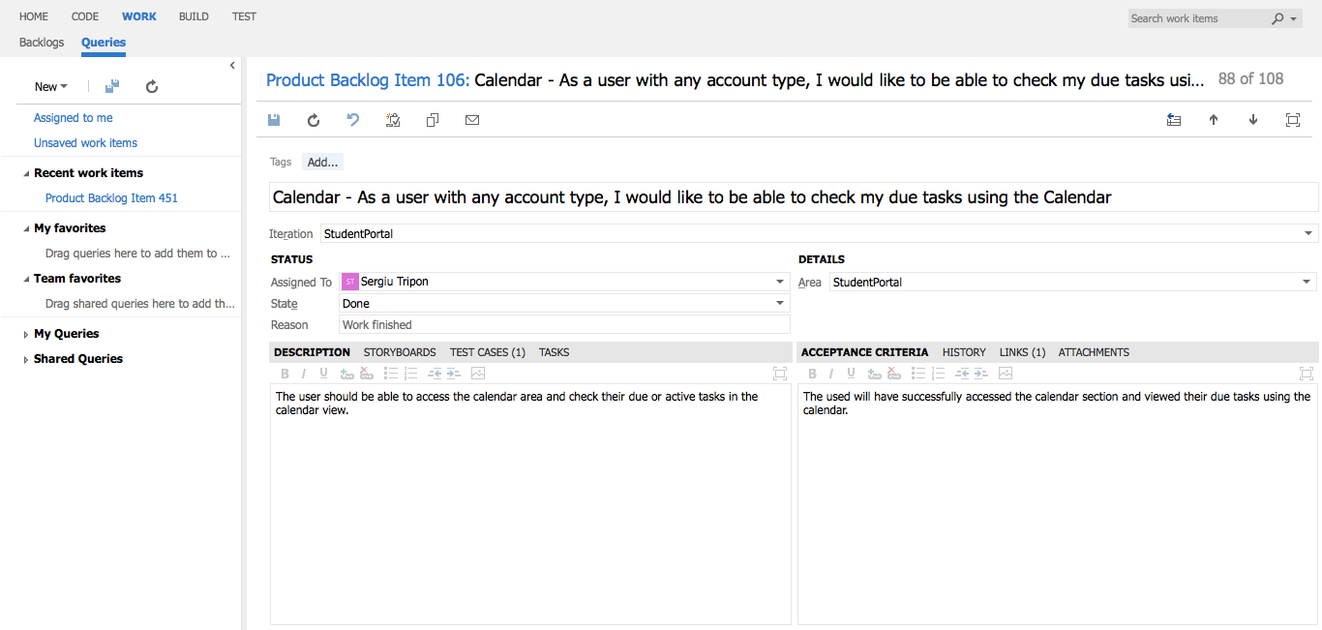

**Calendar** - detailed view of requirement

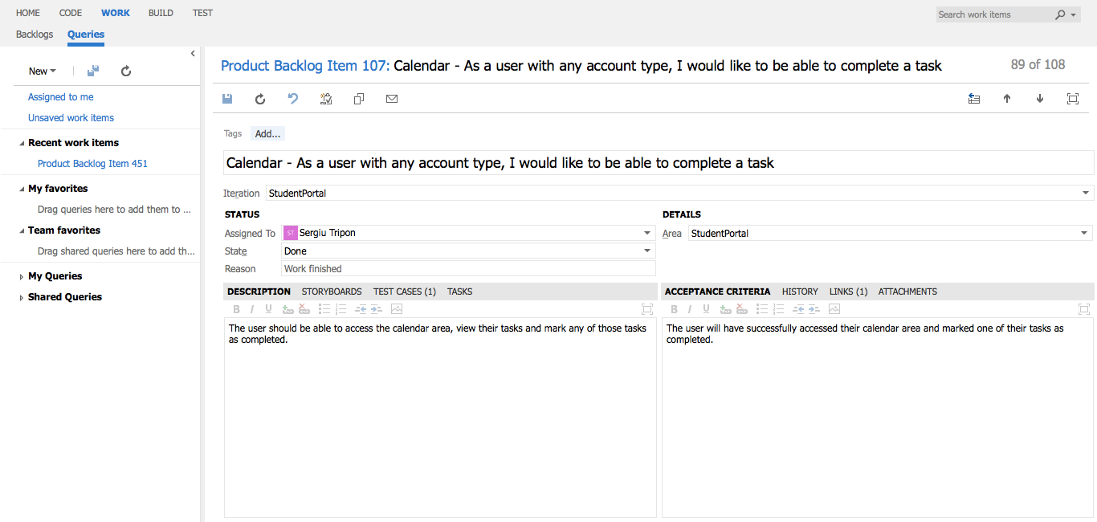

**Calendar** - detailed view of requirement

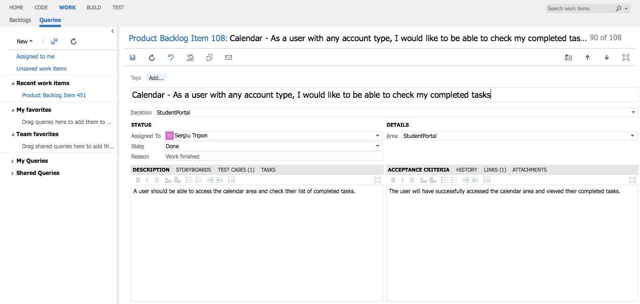

**Calendar** - detailed view of requirement

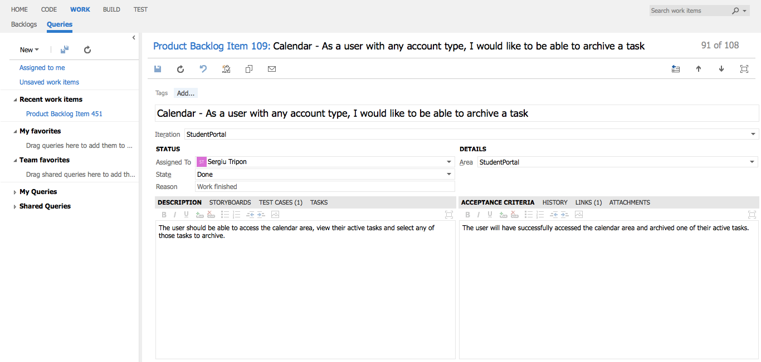

**Calendar** - detailed view of requirement

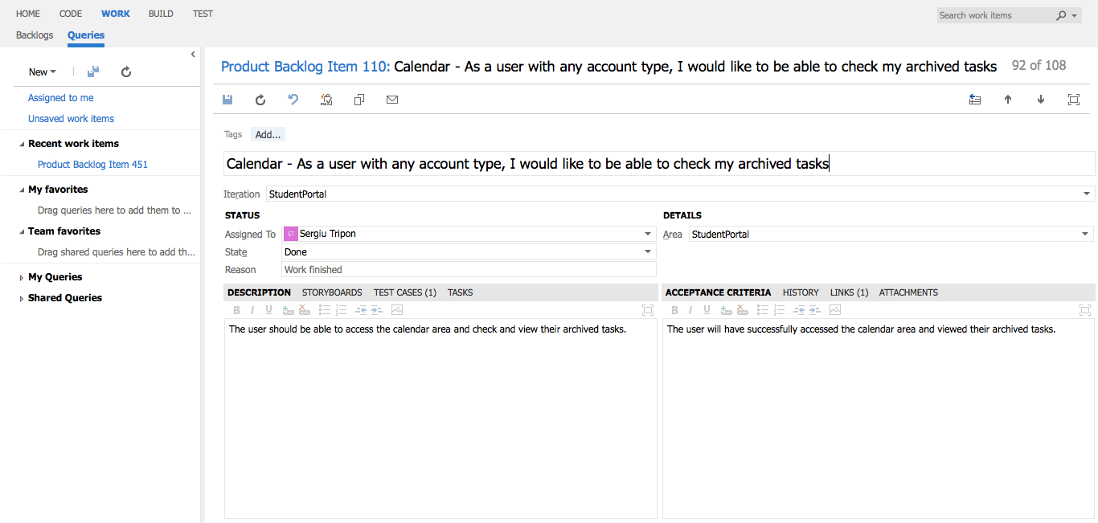

**Calendar** - detailed view of requirement

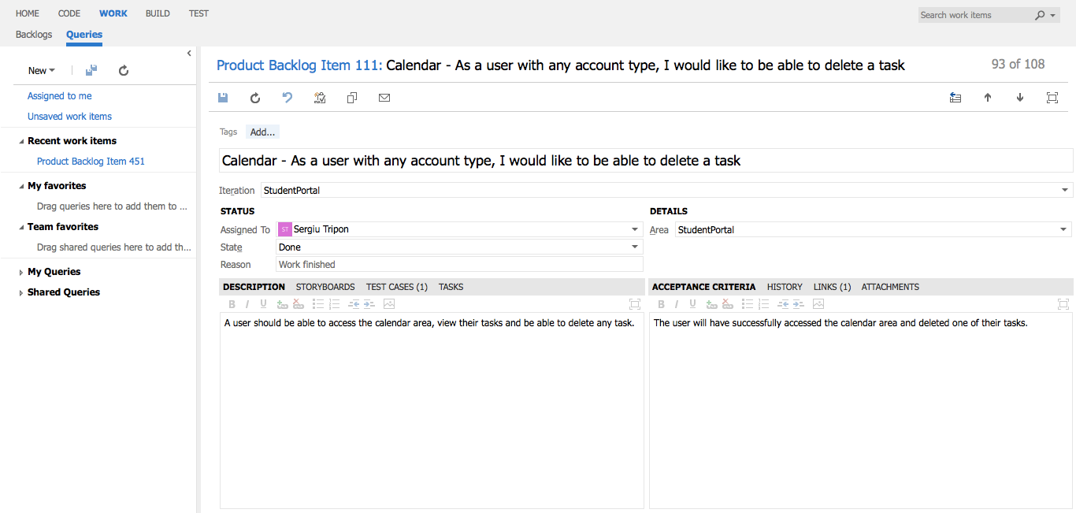

**Calendar** - detailed view of requirement

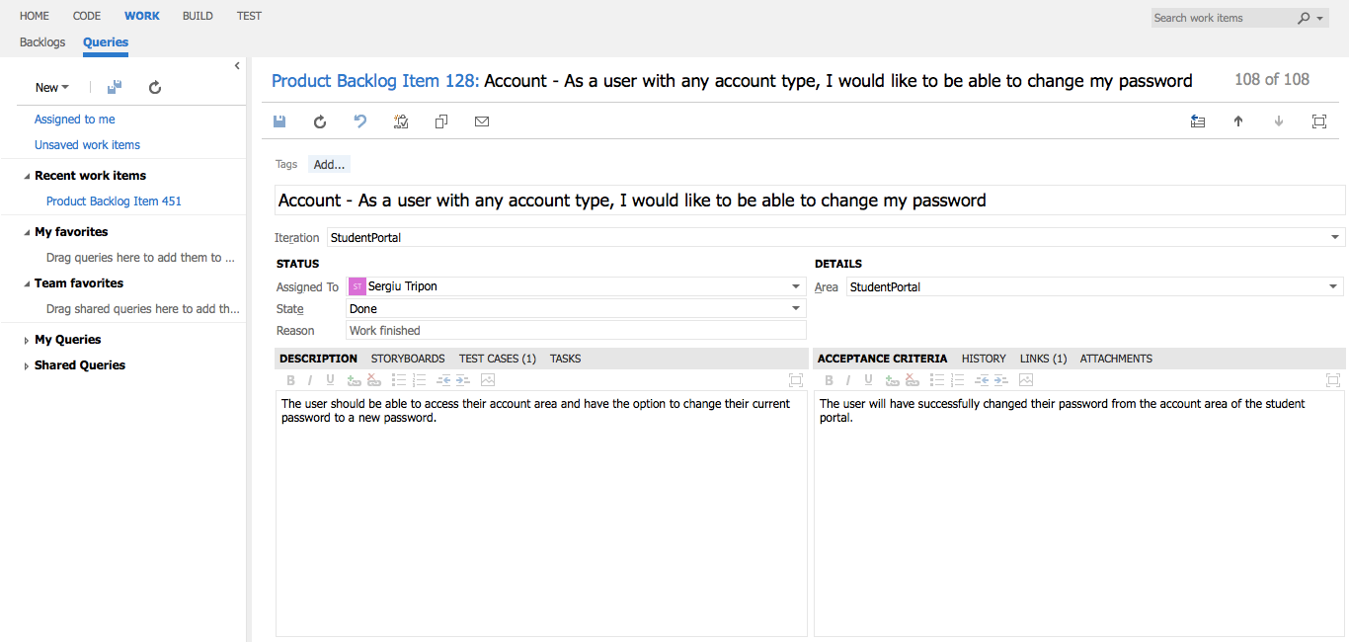

**Account** - detailed view of requirement

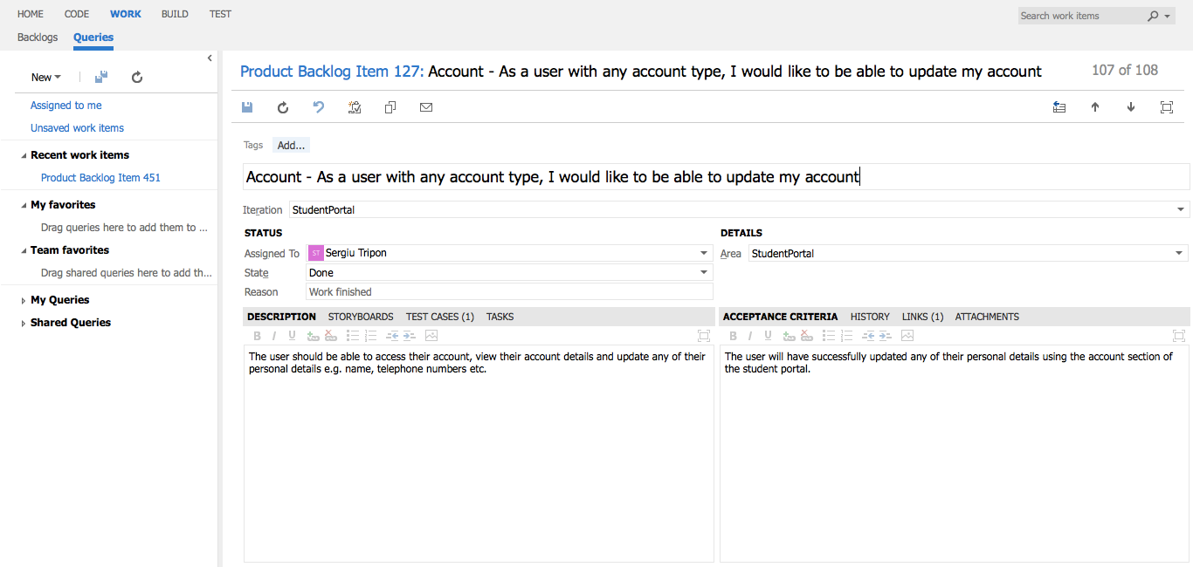

**Account** - detailed view of requirement

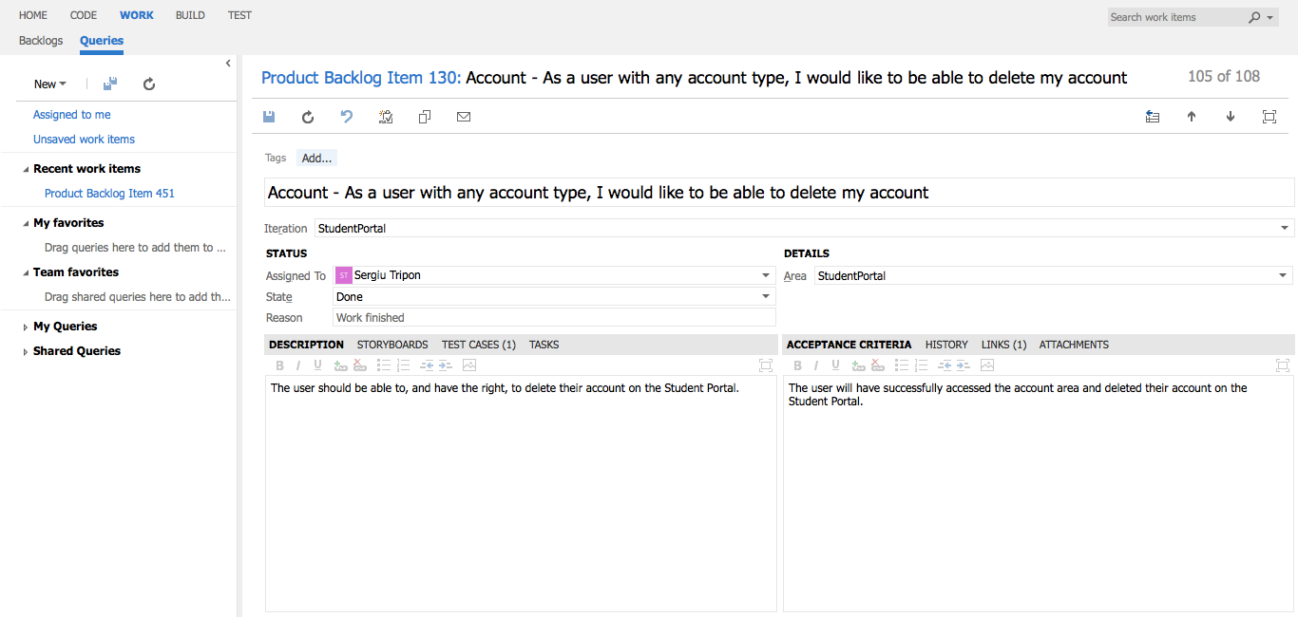

**Account** - detailed view of requirement

## Student, Academic staff

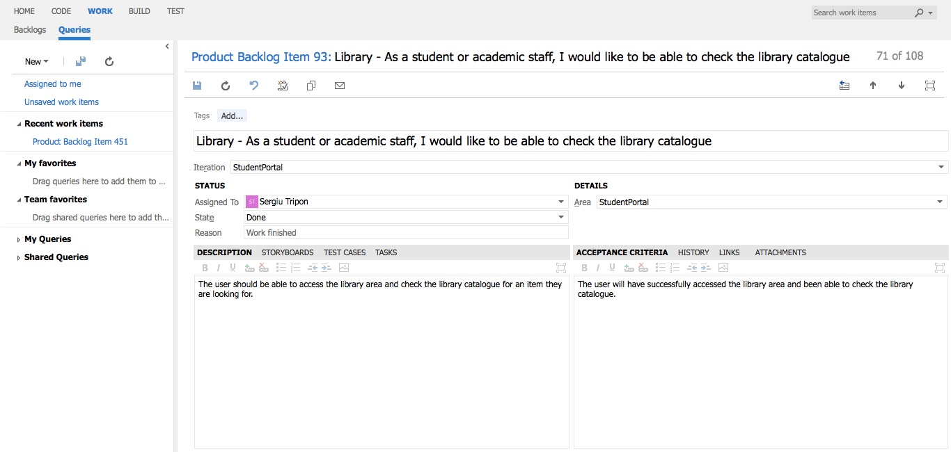

**Library** - detailed view of requirement

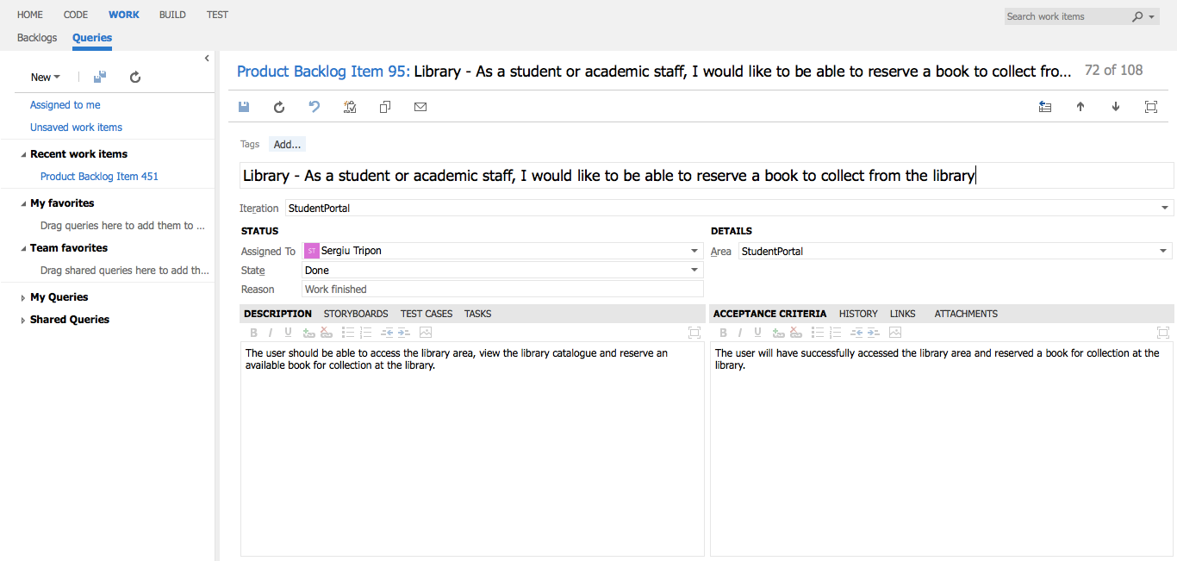

**Library** - detailed view of requirement

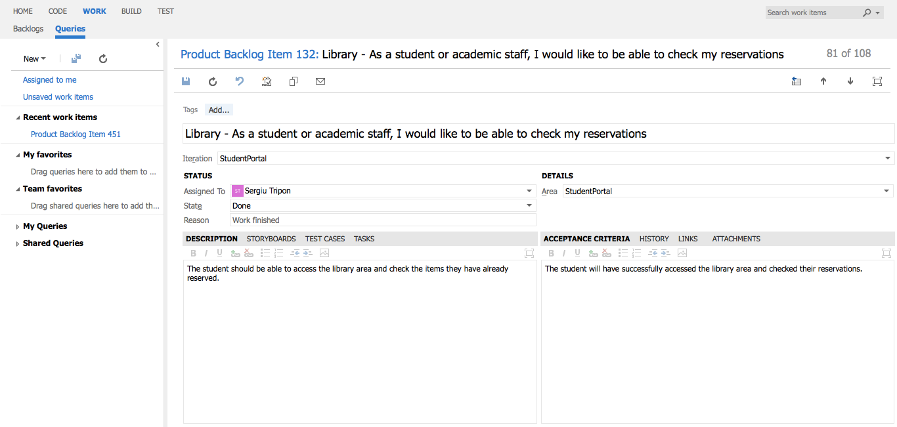

**Library** - detailed view of requirement

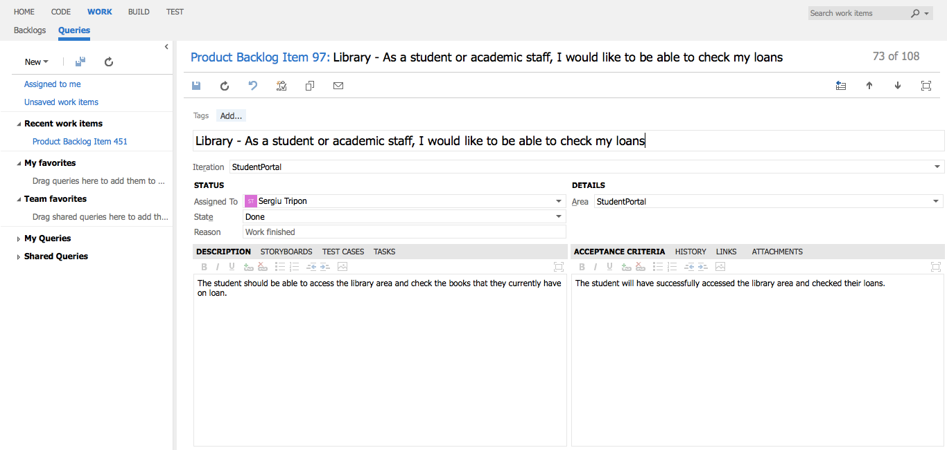

**Library** - detailed view of requirement

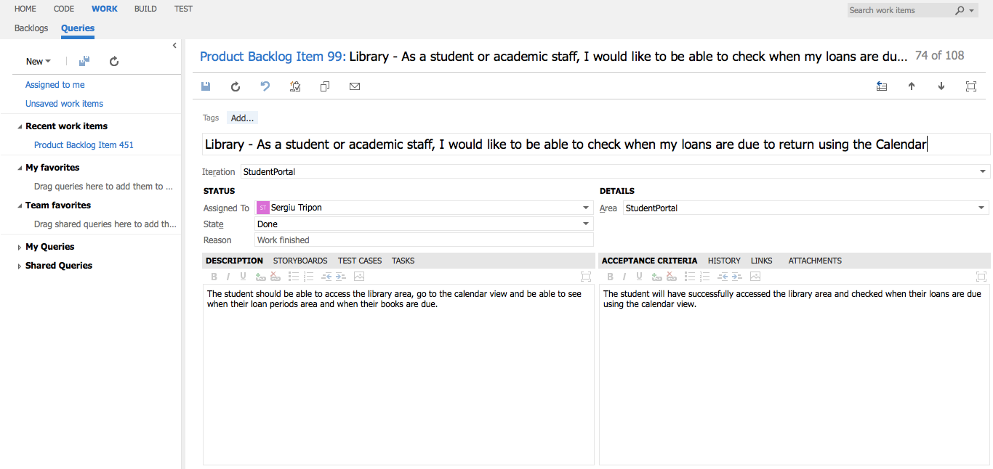

**Library** - detailed view of requirement

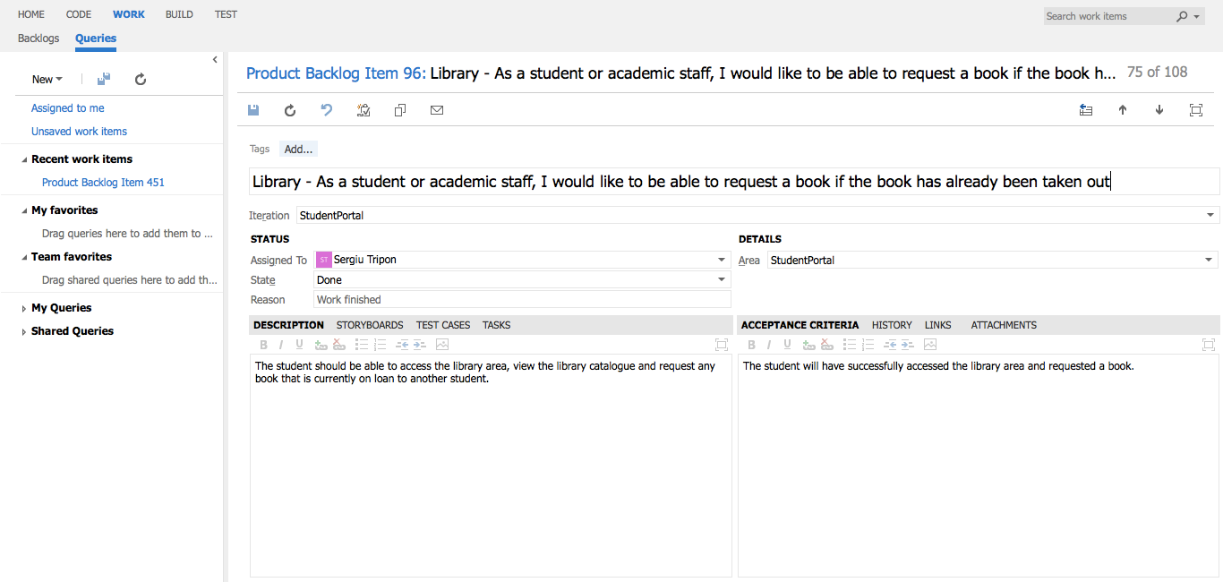

**Library** - detailed view of requirement

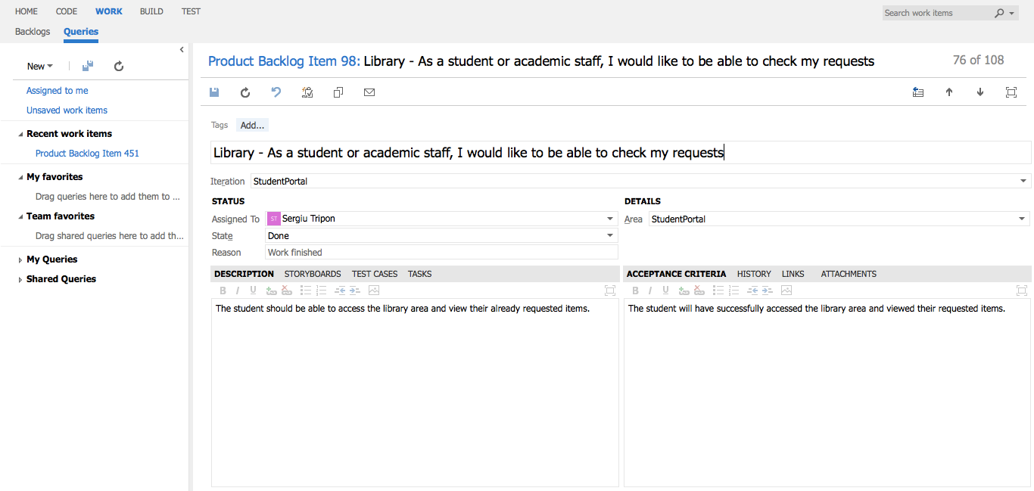

**Library** - detailed view of requirement

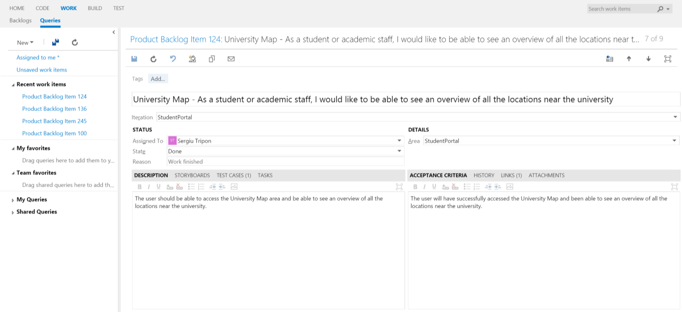

**University Map** - detailed view of requirement

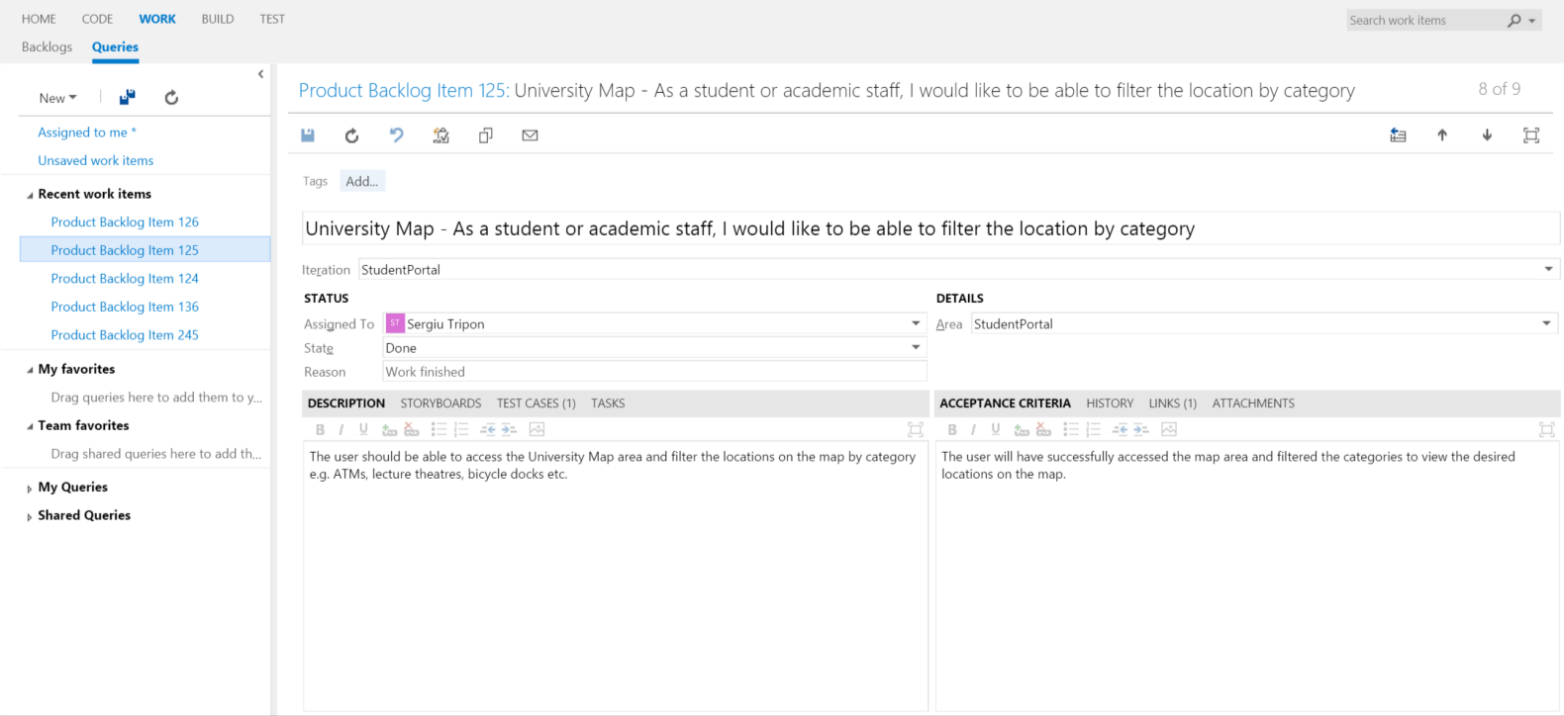

**University Map** - detailed view of requirement

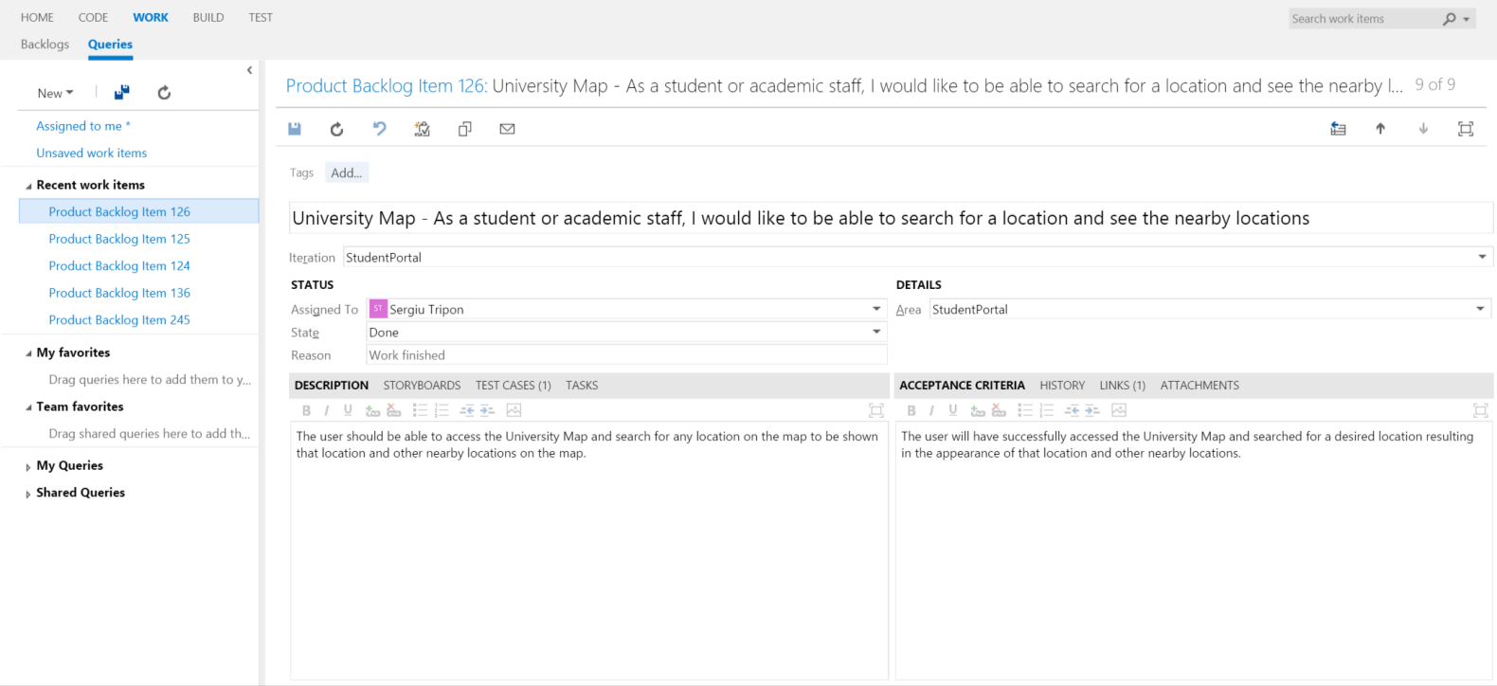

**University Map** - detailed view of requirement

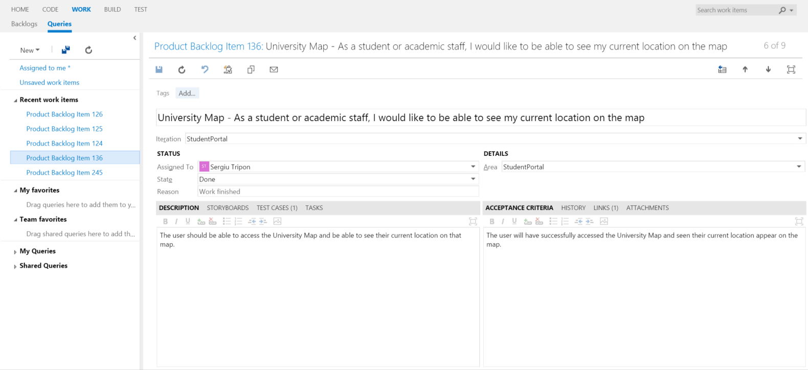

**University Map** - detailed view of requirement

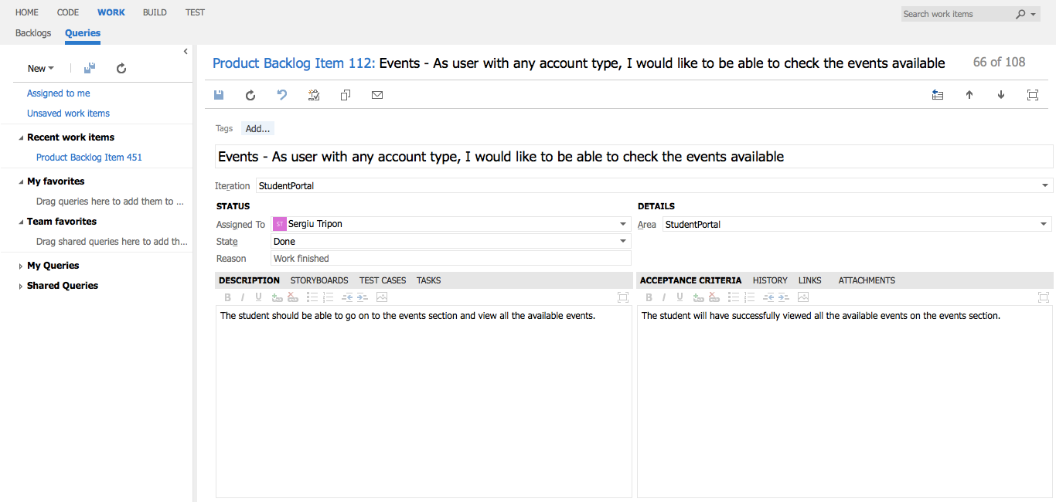

**Events** - detailed view of requirement

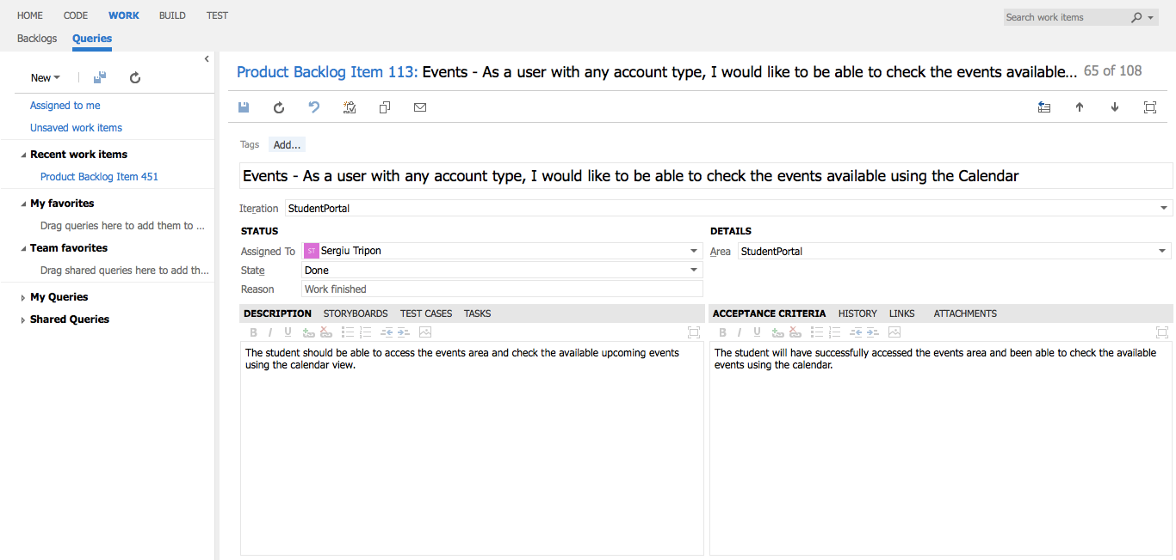

**Events** - detailed view of requirement

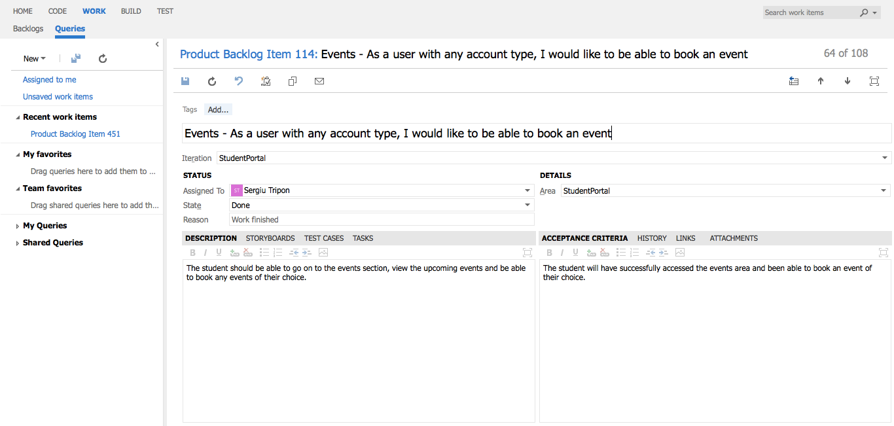

**Events** - detailed view of requirement

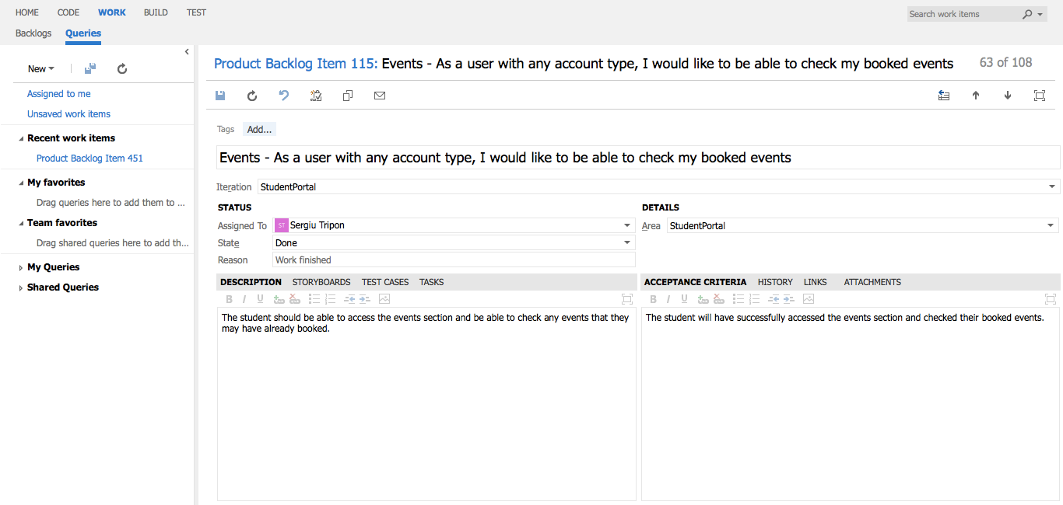

**Events** - detailed view of requirement

## Academic staff, Administrator

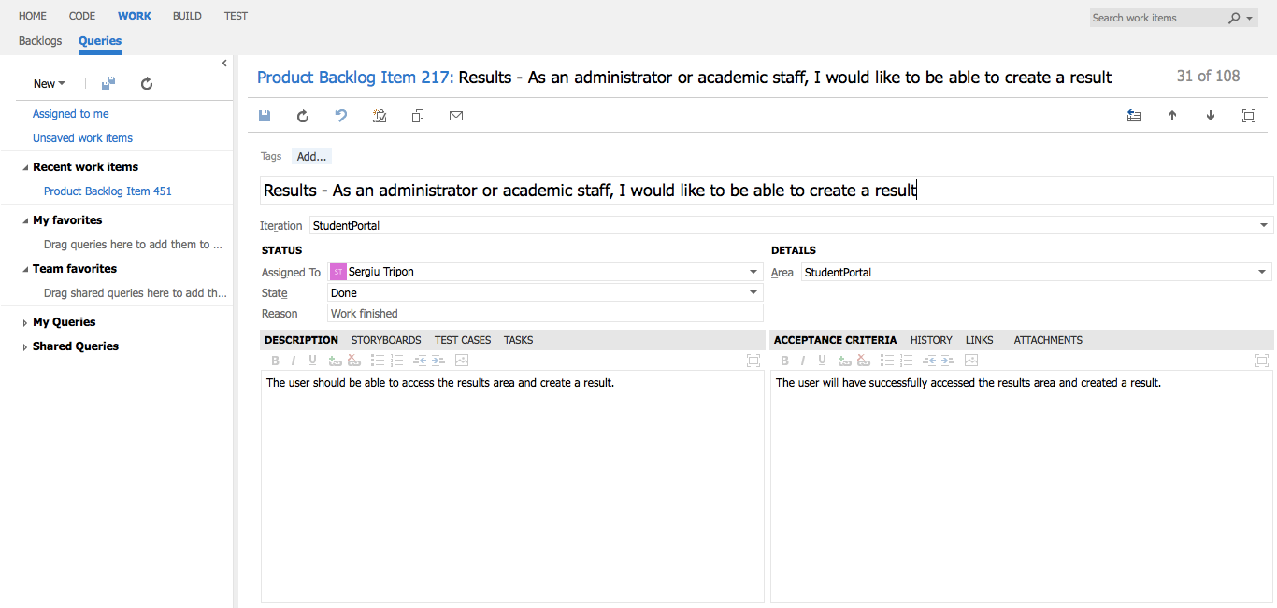

**Results** - detailed view of requirement

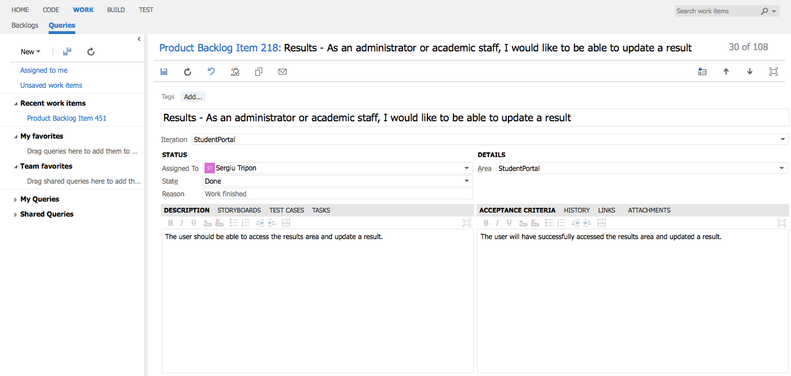

**Results** - detailed view of requirement

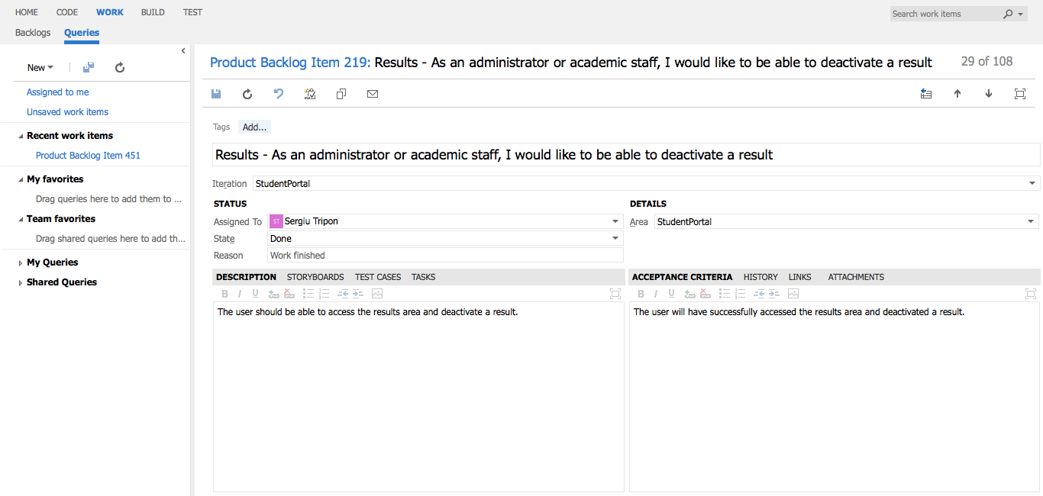

**Results** - detailed view of requirement

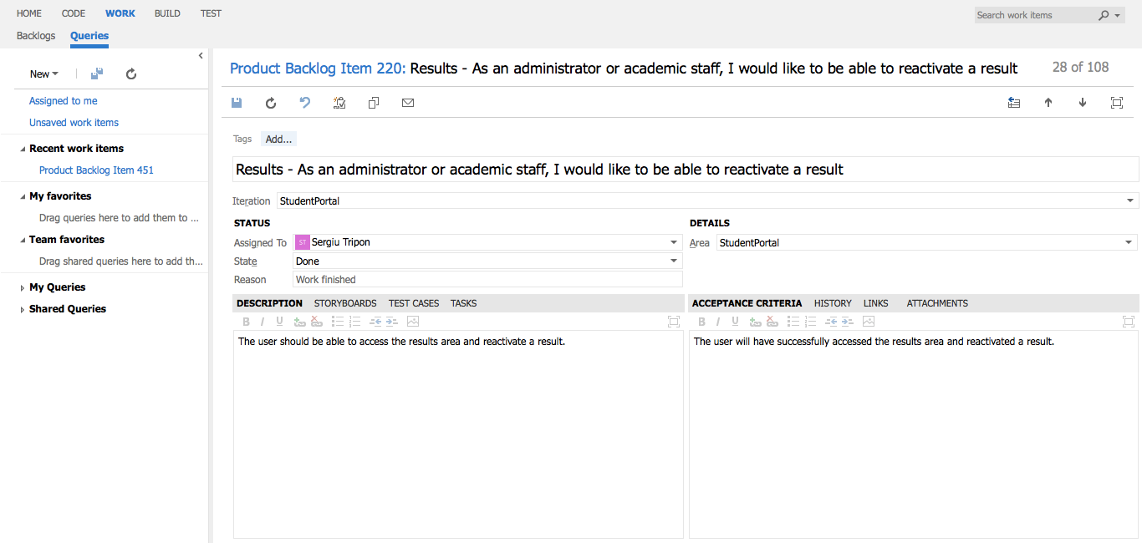

**Results** - detailed view of requirement

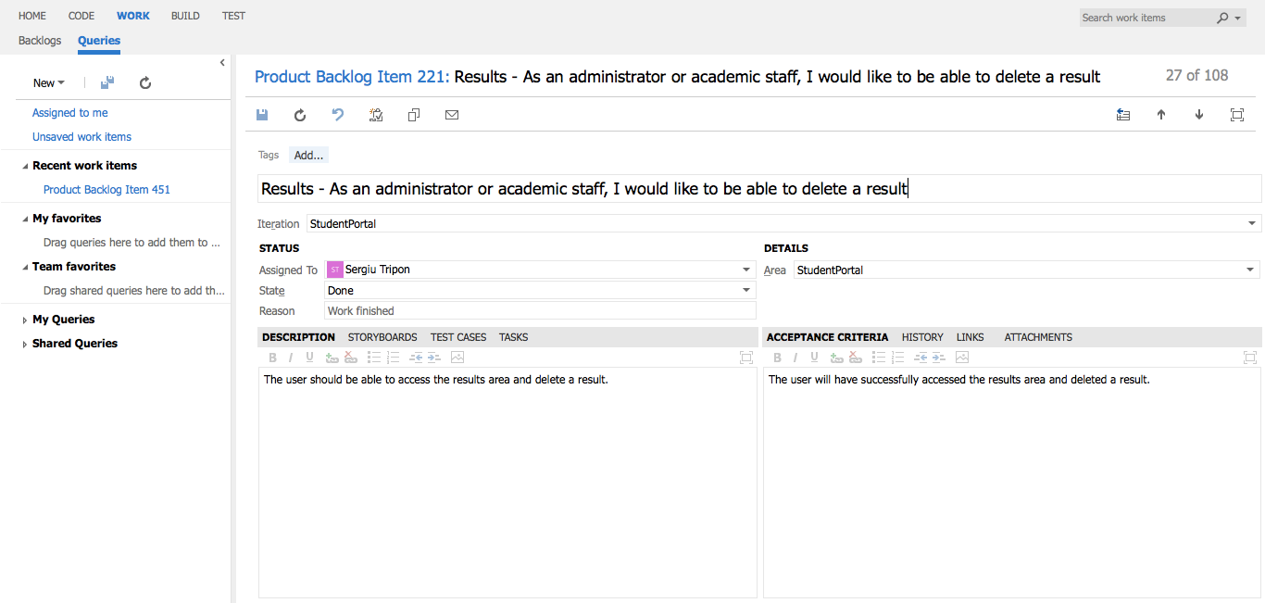

**Results** - detailed view of requirement